PREDICTIVE MODELING AND RISK SCORING
FOR BANK CUSTOMER CHURN
Using European Bank Customer Data

PROJECT REPORT

Submitted by: C.S. Pavithra
Department: Financial Analyst
Institution: Unified Mentor Private Limited
Duration: August to November 2026 (3 Months)

TABLE OF CONTENTS

Contents | Page No.
Executive Summary for Government Stakeholders | 3
CHAPTER 1: INTRODUCTION | 4
1.1–1.7 Background, Problem Statement, Objectives, Research Questions, Scope and Significance | 4
CHAPTER 2: DATASET DESCRIPTION | 8
CHAPTER 3: DATA PREPROCESSING AND FEATURE ENGINEERING | 11
CHAPTER 4: EXPLORATORY DATA ANALYSIS | 14
CHAPTER 5: RESEARCH METHODOLOGY | 27
CHAPTER 6: MODEL DEVELOPMENT | 30
CHAPTER 7: MODEL EVALUATION AND COMPARISON | 31
CHAPTER 8: MODEL EXPLAINABILITY | 37
CHAPTER 9: CHURN RISK SCORING | 41
CHAPTER 10: STREAMLIT APPLICATION | 44
CHAPTER 11: FINDINGS, RECOMMENDATIONS AND LIMITATIONS | 48
CHAPTER 12: CONCLUSION | 51
REFERENCES | 51
APPENDIX A: STREAMLIT APPLICATION SETUP | 52
APPENDIX B: KEY MODEL RESULTS | 52
APPENDIX C: IMPORTANT SUBMISSION CHECKLIST | 52

EXECUTIVE SUMMARY FOR GOVERNMENT STAKEHOLDERS
Customer churn is an important issue for retail banks because losing customers can affect deposits, service income, future product opportunities and long-term customer relationships. This project examines whether the supplied European Bank customer dataset can help identify customers recorded as having exited and demonstrate how churn probabilities can support earlier, more focused retention review.
The dataset contains 10,000 customer records and 14 original columns. The target variable is Exited, where 1 represents a recorded exit and 0 represents a retained customer. The observed churn rate is 20.37%. After data-quality checks, CustomerId, Surname and a constant Year field were excluded from the predictors. Categorical variables were encoded, and four derived features were created. Logistic Regression, Decision Tree, Random Forest and Gradient Boosting were compared using a stratified 80:20 train-test split.
On the 2,000-record test set, Random Forest achieved 85.75% accuracy, 66.76% precision, 59.71% recall, an F1-score of 0.6304 and ROC-AUC of 0.8607. It had the highest ROC-AUC among the four tested models by a very small margin. Gradient Boosting achieved the highest accuracy (86.70%) and precision (81.33%). These results show useful predictive signal in this experiment, but they also show that some churners are missed and some customers may be flagged unnecessarily.
The exploratory analysis found higher observed churn among inactive customers (26.85%) than active customers (14.27%), and higher observed churn in Germany (32.44%) than in France (16.15%) or Spain (16.67%). Product-count groups also showed different churn rates. These are descriptive associations in the supplied sample; they do not prove that a customer attribute causes churn or that changing it will prevent an exit.
The project provides a prototype churn-risk calculator, an illustrative Low/Medium/High classification, feature importance, a what-if simulator and batch scoring. The revised dashboard also reports a probability distribution and a threshold-based binary churn flag. Scores should guide proportionate human review rather than automatically determine customer treatment. Before real use, the model needs calibration, validation on newer and representative data, fairness and privacy review, monitoring, and a threshold selected using campaign costs and capacity. The dataset's provenance has not been independently verified, and the prototype is not connected to live bank systems.

CHAPTER 1: INTRODUCTION

1.1 Background
Customer churn occurs when a customer ends or substantially reduces a relationship with a service provider. In retail banking, losing customers may reduce deposits, fee income, lending opportunities, and future cross-selling potential. Identifying customers who may leave before they do so can help banks prioritize service recovery, engagement, and relevant retention offers.
Traditional descriptive analysis explains patterns after churn has occurred. Predictive modeling adds an estimate of future risk based on historical customer attributes. Such predictions can help teams allocate limited retention resources, provided the model is tested, monitored, and used responsibly.
Customer churn refers to a situation in which a customer stops using a company’s products or services. In banking, churn may mean closing an account, moving regular transactions to another institution, or gradually reducing the relationship until the customer is no longer active. Churn is important because banks invest time and money in attracting customers, opening accounts, maintaining digital services, and providing support. When a customer leaves, the bank may lose current revenue as well as opportunities to offer future products such as deposits, cards, loans, and investment services.
Customer decisions are rarely driven by one factor alone. Age, account balance, credit profile, product usage, customer engagement, service experience, and the availability of competing offers may all be relevant. A traditional report can describe customers who have already left, but a predictive model attempts to estimate the likelihood that a current customer may leave in the future. This changes the focus from only explaining past outcomes to helping a bank decide where early attention may be useful.
Machine learning supports this process by learning patterns from historical examples. A model receives customer attributes as inputs and learns how those attributes relate to the recorded churn outcome. It then produces a probability or risk score for a customer whose outcome is not yet known. Such a score should be treated as decision support rather than certainty: a high score does not prove that a customer will leave, and a low score does not guarantee continued loyalty.

1.2 Problem Statement
Banks may hold large volumes of customer data but lack a consistent, measurable way to prioritize customers who may churn. Without predictive scores and interpretable evidence, retention campaigns may be reactive, broad, and costly. This project evaluates whether customer-level features can support churn prediction and risk scoring.
The central problem addressed in this study is that customer churn may be identified too late if a bank relies only on retrospective reports or manual observation. By the time a customer closes an account, the opportunity to understand dissatisfaction or offer an appropriate retention action may already have passed. A large customer base also makes it difficult for staff to assess every customer individually with equal depth.

The project therefore investigates whether the available customer-level dataset contains useful signals for distinguishing customers recorded as churned from those recorded as retained. It compares several supervised classification models and evaluates their performance on data held out from model training. The study also explores how predicted probabilities can be converted into understandable risk categories and how model explanations may support responsible business interpretation.
The problem is not simply to achieve the highest accuracy. Churn datasets often contain more retained customers than churned customers, so a model can appear accurate while missing many customers who actually leave. The analysis must therefore consider recall, precision, F1-score, ROC-AUC, and the business consequences of false alarms and missed churn cases.

1.3 Primary Objectives
- Build and compare machine-learning models to predict customer churn.
- Generate a churn probability between 0 and 1 for each scored customer.
- Identify important predictors associated with model outputs.
The primary objective is to develop and evaluate a predictive modeling workflow that estimates the likelihood of bank customer churn using the supplied European Bank customer data. The workflow includes data inspection, preprocessing, exploratory analysis, feature preparation, model training, evaluation, and the interpretation of risk scores.
The second part of the primary objective is comparative. Logistic Regression, Decision Tree, Random Forest, and Gradient Boosting are considered because they represent different modeling approaches. Comparing them under the same train-test split allows the study to identify strengths and limitations rather than assuming that one algorithm is best in every situation.

1.4 Secondary Objectives
- Evaluate false-positive and false-negative behavior using precision, recall, and confusion matrices.
- Improve interpretability through feature importance, SHAP where available, and partial dependence.
- Provide a scenario-based risk calculator through a Streamlit prototype.
The supporting objectives are to describe the dataset and its target variable; identify missing, duplicated, inconsistent, or non-informative fields; explore how selected customer characteristics relate to recorded churn; and construct additional features that may capture useful relationships among existing variables.
Further objectives are to interpret model metrics in practical terms, examine the relative contribution of features, create an illustrative probability-based risk score, and design a Streamlit interface through which a user can enter customer details and inspect a model prediction. The project also records limitations and proposes improvements needed before any real banking deployment.

1.5 Research Questions
- How accurately can churn be predicted from the available customer features?
- Which of the evaluated models provides the strongest discrimination on the held-out test set?
- Which features contribute most to the selected model's predictions?
- How can churn probabilities be translated into practical risk categories and explored through a web interface?
The research questions guide the analysis from description to evaluation. First, what is the distribution of churned and retained customers in the dataset? Second, how do churn rates vary across available demographic, account, and engagement characteristics? Third, which of the tested classification models performs most effectively on the held-out data under the selected evaluation criteria?
Additional questions concern interpretability and practical use: which features appear influential in the fitted model, how can predicted probabilities be translated into risk categories, and how could a bank use a score to prioritize further review? These questions are answered using the available data and model results; they do not establish causal relationships or prove that a particular retention action will prevent churn.

1.6 Scope
The study uses the supplied 10,000-row CSV. It focuses on supervised classification, evaluation on one stratified holdout split, risk scoring, and a prototype interface. It does not include live bank systems, real customer contact, causal inference, or external validation on another bank or later time period.
The study is limited to the supplied customer-level dataset and the target field named Exited, where 1 represents a customer recorded as having exited and 0 represents a customer recorded as retained. The analysis covers data quality checks, exploratory data analysis, feature engineering, four classification algorithms, performance comparison, explainability concepts, probability-based risk scoring, and a prototype Streamlit application.
The project does not include direct customer interviews, bank transaction histories over time, complaint records, customer-service interactions, or experimentally tested retention campaigns unless those are separately provided. Consequently, the analysis should be interpreted as a demonstration of predictive analytics on the supplied fields, not a complete operational churn-management system.

1.7 Significance
The project demonstrates a repeatable analytical workflow for prioritizing retention analysis. It also highlights the need to balance overall correctness with the ability to detect churners, to explain model limitations, and to protect customer information.
The academic significance of the project is that it combines statistical thinking, data preparation, machine learning, performance evaluation, and business interpretation within one applied finance and banking problem. It demonstrates why model comparison requires more than one score and why data quality and validation are essential parts of a predictive workflow.
The practical significance is the possibility of helping a bank organize customer outreach. A score can support prioritization when staff time or retention budgets are limited. However, a score should be used with appropriate privacy safeguards, human review, and monitoring. The bank should investigate the reasons for possible churn and select helpful interventions rather than treating the prediction as a fixed judgment about a customer.

CHAPTER 2: DATASET DESCRIPTION

2.1 Dataset Source
The dataset used is the user-supplied file named European_Bank(1).csv. The project does not independently verify the dataset's institutional origin or representativeness. It is therefore described as the supplied European bank customer dataset rather than as a verified extract from a named bank or regulator.
The project uses the supplied file named European_Bank(1).csv. It is treated as secondary data because the student analyses an existing dataset rather than collecting original responses directly from customers. Secondary data can make a project feasible within an academic timeline and supports reproducible analysis when the source file and preparation steps are documented.
The dataset name alone does not verify the real-world origin, collection procedure, or representativeness of the records. Therefore, the report describes it as the supplied European Bank customer dataset and avoids making unsupported claims about a particular bank, country-level population, or data collection process. For a formal submission, the student should include the actual source citation or dataset URL if it was provided by the instructor or downloaded from a public repository.

2.2 Dataset Dimensions
The dataset contains 10,000 customer records. Each row represents one customer record, while columns represent attributes associated with that customer and the recorded churn outcome. The original fields include CustomerId, Surname, CreditScore, Geography, Gender, Age, Tenure, Balance, NumOfProducts, HasCrCard, IsActiveMember, EstimatedSalary, Exited, and a Year field in the supplied version.
Rows and columns have different analytical roles. CustomerId is an identifier, Surname is a name-like field, and Exited is the outcome the model is intended to predict. Geography and Gender are categorical variables; CreditScore, Age, Tenure, Balance, NumOfProducts, and EstimatedSalary are numeric or count-like fields; HasCrCard and IsActiveMember are binary indicators. The Year field is constant in the supplied version and therefore cannot distinguish one customer from another.
Item | Observed value
Rows / customer records | 10,000
Original columns | 14
Missing cells | 0
Fully duplicated rows | 0
Target variable | Exited
Retained customers | 7,963 (79.63%)
Churned customers | 2,037 (20.37%)

2.3 Variable Description
CreditScore represents a customer credit-score value; Age represents age; Tenure represents the number of years or tenure units recorded for the customer; Balance represents the recorded account balance; NumOfProducts represents the number of products held; and EstimatedSalary represents an estimated salary amount. Geography and Gender identify categorical groupings, while HasCrCard indicates card ownership and IsActiveMember indicates the recorded activity status.
Variable meaning should be confirmed against the dataset documentation before a production use case. In particular, the dataset does not establish from the field names alone how balance and salary are measured, when they were captured, or whether all values were available before the churn outcome occurred. Those details matter because a valid prediction must use only information that would have been known at the time the prediction is made.
Variable | Meaning | Model treatment
Year | Year label; constant at 2025 in this file | Excluded: no variation
CustomerId | Unique customer identifier | Excluded
Surname | Customer surname | Excluded
CreditScore | Creditworthiness indicator | Numeric predictor
Geography | France, Spain, Germany | One-hot encoded
Gender | Male / Female | One-hot encoded
Age | Customer age | Numeric predictor
Tenure | Years with bank | Numeric predictor
Balance | Account balance | Numeric predictor
NumOfProducts | Number of bank products | Numeric predictor
HasCrCard | Credit card ownership flag | Binary predictor
IsActiveMember | Activity indicator | Binary predictor
EstimatedSalary | Estimated annual salary | Numeric predictor
Exited | 1 = churned; 0 = retained | Target variable

2.4 Target Definition
Exited is the dependent variable. A value of 1 represents a customer who exited, while 0 represents a retained customer. The model's positive-class probability is interpreted as estimated churn probability. A predicted probability is not a guarantee that an individual will churn.
The target variable is Exited. A value of 1 indicates that the customer is recorded as having exited, while a value of 0 indicates that the customer is recorded as retained. The target is binary, making this a supervised binary classification problem. During training, the algorithms use the input variables and known target values to learn patterns associated with the two classes.
The target should be checked for valid values, missing observations, and class balance before modeling. The analysis reported a churn rate of approximately 20.37% and a retained-customer share of approximately 79.63%. This imbalance is not extreme, but it is large enough that overall accuracy alone could hide weak performance on the churn class.

2.5 Dataset Characteristics
The dataset is imbalanced: 7,963 customers (79.63%) are retained and 2,037 (20.37%) are churned. A model that predicts every customer as retained would achieve 79.63% accuracy but would fail to identify churners; therefore multiple metrics are required.
The dataset combines demographic, geographic, account, product, and engagement information. This mixture is useful because churn may relate to several aspects of a customer relationship rather than one isolated attribute. For example, product count and active-member status may provide information about engagement, while age or geography may reveal differences between customer segments.
At the same time, the dataset is a snapshot rather than a full time-series record. It does not directly describe changes in customer behavior, monthly transaction activity, complaints, digital usage, service failures, or the timing of interactions before exit. Predictive patterns found in this dataset should therefore be viewed as patterns within the available fields, not a complete explanation of why customers leave.
CHAPTER 3: DATA PREPROCESSING AND FEATURE ENGINEERING

3.1 Data Quality Checks
The CSV was loaded and checked for missing cells, duplicated rows, column names, and target values. There are 0 missing cells and 0 fully duplicated rows. Since no missing values were observed in the supplied data, no row deletion or imputation was required for the original dataset. The modeling pipeline nevertheless includes median imputation for numeric columns to make the workflow more robust to future inputs.
Preprocessing begins by loading the CSV file and checking the number of rows and columns, column names, data types, missing values, duplicate records, and descriptive statistics. The target distribution is checked separately because it determines the baseline churn rate and helps identify whether a stratified split is needed. Categorical values should also be inspected for inconsistent spelling, leading spaces, or unexpected categories.
Missing-value handling should be selected according to the variable and the amount of missingness. Numeric variables may be imputed using a median and categorical variables using a most-frequent category, but the decision must be based on the observed data rather than applied automatically. If the supplied dataset has no missing values, the report should state that no imputation was required after the check. Outliers should be examined for plausibility before any removal or transformation.

3.2 Identifier Removal
CustomerId and Surname were removed from the predictor set because they identify customers rather than provide a defensible generalizable behavioral signal. Year was also removed because it is constant at 2025 for every record and cannot distinguish churn outcomes.
CustomerId is removed because it identifies a record rather than describing a meaningful customer behavior. Surname is also excluded from the main model because it is a personal name field, offers no obvious operational explanation for churn, and may introduce privacy and fairness concerns. A model can sometimes learn accidental associations from identifiers or names, but such associations are unlikely to generalize reliably.
The Year field is removed if it is constant across all rows. A constant variable contains no variation for a model to use when distinguishing churned from retained customers. Removing these fields reduces noise and helps the analysis focus on attributes with a plausible relationship to the customer account or engagement.

3.3 Categorical Encoding
Geography and Gender are categorical variables. One-hot encoding converts them into numerical indicator columns. The fitted preprocessing pipeline uses handle_unknown='ignore' so an unexpected category does not cause a pipeline error, although unknown categories should still be reviewed.
Most machine-learning algorithms require categorical variables to be represented numerically. Geography and Gender are therefore converted using one-hot encoding, which creates indicator columns for categories. This avoids assigning an artificial numerical order to categories that are nominal rather than ranked.
Encoding must be fitted only on the training data and then applied consistently to the test data. A pipeline helps ensure that the same transformations are used during evaluation and later prediction. Unknown categories encountered in future customer records should be handled deliberately—for example, with an encoder configured to ignore unseen categories—rather than causing the application to fail.

3.4 Numerical Scaling
StandardScaler is applied to numeric predictors for Logistic Regression because coefficient-based linear models can be sensitive to differing feature scales. Tree-based models do not require standardization, so the same numeric columns are passed through without scaling for Decision Tree, Random Forest, and Gradient Boosting.
Numerical scaling changes the scale of numeric predictors so that variables measured in large units do not dominate simply because their values are larger. Logistic Regression can benefit from standardization because its optimization and coefficient estimates are sensitive to the relative scales of input features. Tree-based algorithms such as Decision Tree, Random Forest, and Gradient Boosting generally do not require standardization because their splits are based on feature thresholds.
Scaling parameters must be learned from the training set only. If the mean and standard deviation are calculated using the full dataset before splitting, information from the test set leaks into the training process. A pipeline prevents this by fitting the scaler during training and applying the learned transformation to the held-out data.

3.5 Feature Engineering
Derived feature | Calculation / definition | Reason
BalanceToSalaryRatio | Balance / EstimatedSalary; zero salary handled as missing | Represents balance relative to estimated salary
ProductDensityIndicator | 1 if NumOfProducts >= 2, otherwise 0 | Simple indicator of multiple-product holding
EngagementProductInteraction | IsActiveMember × NumOfProducts | Combines engagement and product count
AgeTenureInteraction | Age × Tenure | Represents an age-tenure interaction

These definitions are project-specific engineering choices. The ratios and interaction terms are associations available to the model, not proven causes of churn. Future deployments should inspect outliers and test whether each engineered feature improves out-of-sample performance.
Feature engineering creates additional predictors from existing fields when the derived values may capture a useful relationship. The project includes BalanceToSalaryRatio, calculated as Balance divided by EstimatedSalary with safe handling when the denominator is zero; ProductDensityIndicator, which indicates whether NumOfProducts is at least two; EngagementProductInteraction, calculated as IsActiveMember multiplied by NumOfProducts; and AgeTenureInteraction, calculated as Age multiplied by Tenure.
These features represent hypotheses, not guaranteed improvements. Balance relative to estimated salary may describe the scale of a customer’s balance in relation to income, while the product indicator may distinguish customers with more than one product. The interaction features allow the model to consider combinations of activity, product count, age, and tenure. Their value must be tested on held-out data; engineered features should be retained only when they are computed consistently and do not introduce leakage.

3.6 Train-Test Split
The dataset was split into 80% training data and 20% test data using stratification on Exited and random_state=42. This produces 8,000 training records and 2,000 test records while preserving the class distribution approximately. The test set was held out from model fitting and used for the reported metrics.
The data is divided into training and test subsets using an 80:20 split. The training portion is used to fit preprocessing steps and model parameters; the test portion is held aside to estimate how well the fitted model performs on records it did not train on. Stratification is used so that the approximate proportion of churned and retained customers is maintained in both subsets.
A fixed random seed makes the split reproducible. The test set should not be repeatedly used to make many modeling decisions, because doing so can indirectly overfit the process to the test data. If the project is extended, cross-validation within the training data can support model selection, followed by one final evaluation on the untouched test set.

3.7 Leakage Prevention
Preprocessing transformations are fitted inside scikit-learn pipelines using training data only. The target variable and customer identifiers are not included in model predictors. The test data is used only for final evaluation in this experiment.
Data leakage occurs when a model receives information during training that would not legitimately be available at the time of a real prediction. Leakage can create impressive test metrics that fail in practice. In this project, identifiers and non-informative fields are excluded, transformations are fitted on training data, and the target Exited is kept separate from the predictors.
A further temporal check is important before deployment: all predictor values must be available before the churn event being predicted. If balance, activity, or any other field was recorded after exit, it may reveal the outcome indirectly. The supplied data does not by itself document the exact observation date for each feature, so this remains a limitation to address before operational use.
CHAPTER 4: EXPLORATORY DATA ANALYSIS

4.1 Churn Distribution
The dataset contains 2,037 churned customers (20.37%) and 7,963 retained customers (79.63%). The imbalance means recall and precision must be considered alongside accuracy.
Churn Status | Number of Customers | Percentage
Stayed (0) | 7,963 | 79.63%
Exited (1) | 2,037 | 20.37%
Total | 10,000 | 100%

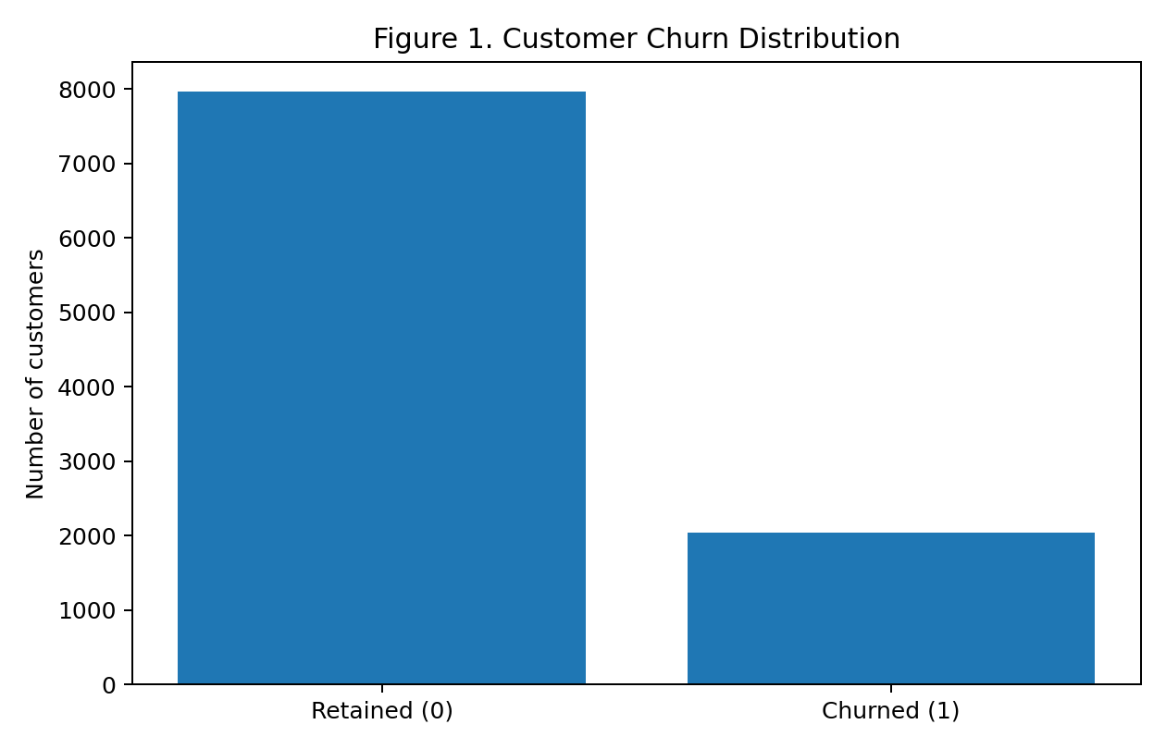
Figure 1. Distribution of retained and churned customers.
Interpretation: Retained customers represent 79.63% of the dataset, while 20.37% have churned. Because the classes are imbalanced, accuracy alone may hide poor churn detection; precision, recall, F1-score and ROC-AUC are also important.
Exploratory Data Analysis (EDA) begins with the distribution of Exited. Approximately 20.37% of records belong to the churn class and 79.63% to the retained class. This means that roughly one in five records is labeled as churned in the supplied sample. The class distribution provides a baseline against which model performance can be assessed.
The imbalance means a model that predicts every customer as retained could achieve close to 79.63% accuracy while identifying no churned customers at all. This is why the project reports recall, precision, F1-score, and ROC-AUC in addition to accuracy. In business terms, identifying likely churners is often the key purpose of the model, so the ability to detect the minority class matters.

4.2 Churn by Geography
Germany: 32.44% observed churn rate.
Spain: 16.67% observed churn rate.
France: 16.15% observed churn rate.
Geography | Total Customers | Exited | Churn Rate
France | 5,014 | 810 | 16.15%
Germany | 2,509 | 814 | 32.44%
Spain | 2,477 | 413 | 16.67%

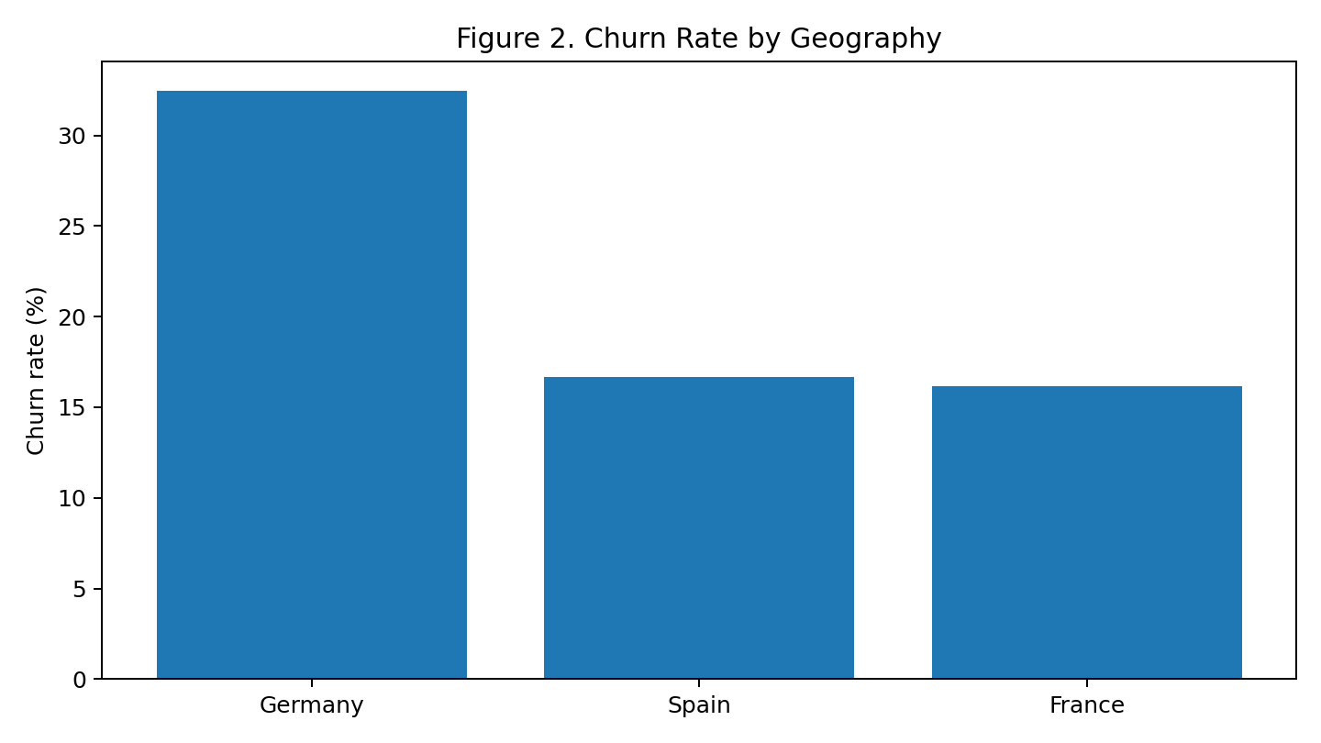
Figure 2. Observed churn rate by geography.
Interpretation: The chart compares churn rates across the three geographies. Differences suggest that churn patterns vary by location in this dataset, but geography should be treated as an association rather than a cause.
Comparing churn rates by Geography helps investigate whether the recorded outcome differs across the geographic categories represented in the dataset. A useful analysis compares within-group churn percentages rather than only comparing raw counts, because groups may contain different numbers of customers. A category with more churned customers may simply have a larger customer base.
Geographic differences may reflect variation in customer mix, product preferences, competition, service channels, or other factors not represented in the file. The analysis can identify an association but cannot establish that geography itself causes churn. Before acting on these differences, a bank should confirm that categories are defined consistently and that the results are supported by enough observations in each group.

4.3 Churn by Gender

Gender | Total Customers | Exited | Churn Rate
Female | 4,543 | 1,139 | 25.07%
Male | 5,457 | 898 | 16.46%

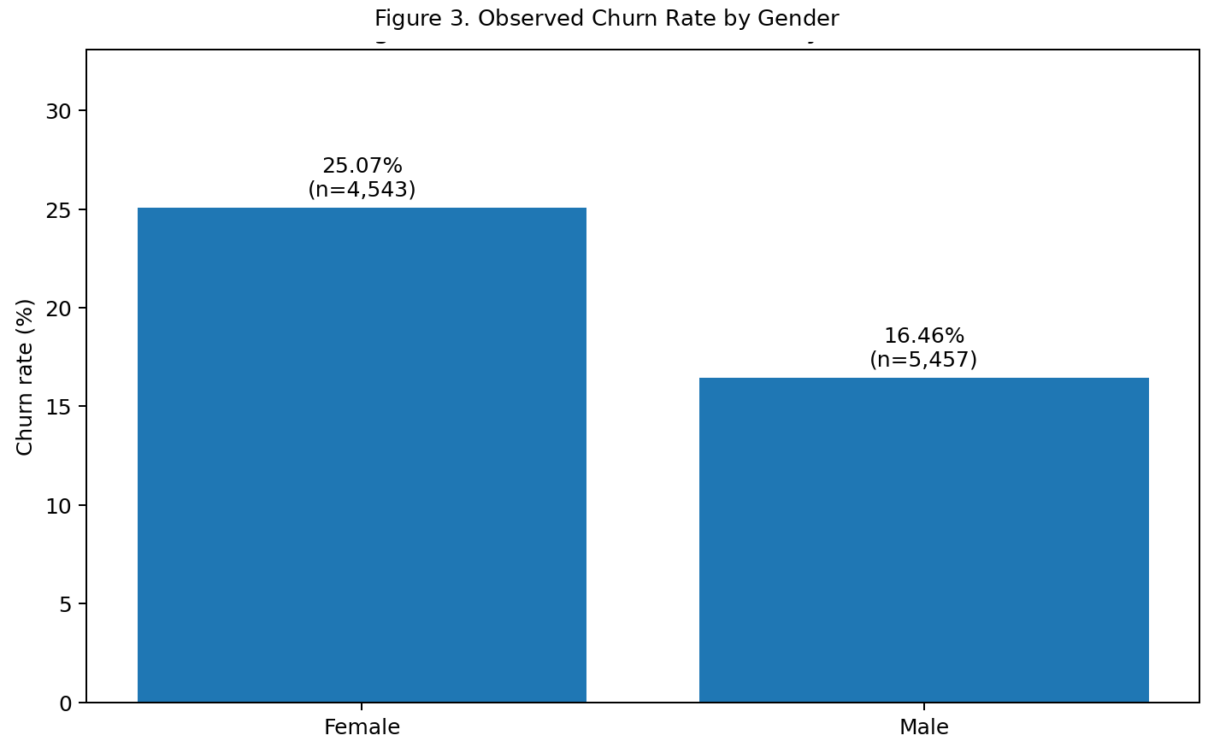
Figure 3. Observed Churn Rate by Gender.

Interpretation: Compare observed churn rates between gender groups. Any difference is descriptive and should be checked for fairness and consistency before guiding customer treatment.
Female: 25.07% observed churn rate.
Male: 16.46% observed churn rate.
Churn percentages by Gender can be compared to see whether the recorded churn outcome varies between the categories available in the dataset. The analysis should report the size of each group alongside the percentage that exited, because percentages based on very small groups can be unstable.
Any observed difference should be interpreted cautiously. Gender is a sensitive demographic attribute in many decision settings, and a difference in historical churn does not automatically justify using gender in individual decisions. A responsible bank should assess fairness, applicable law, business necessity, and whether less sensitive variables can support the same legitimate objective.

4.4 Age

Statistic | Overall | Stayed | Exited
Mean | 38.92 | 37.41 | 44.84
Median | 37 | 36 | 45
Minimum | 18 | 18 | 18
Maximum | 92 | 92 | 84
Standard Deviation | 10.49 | 10.13 | 9.76

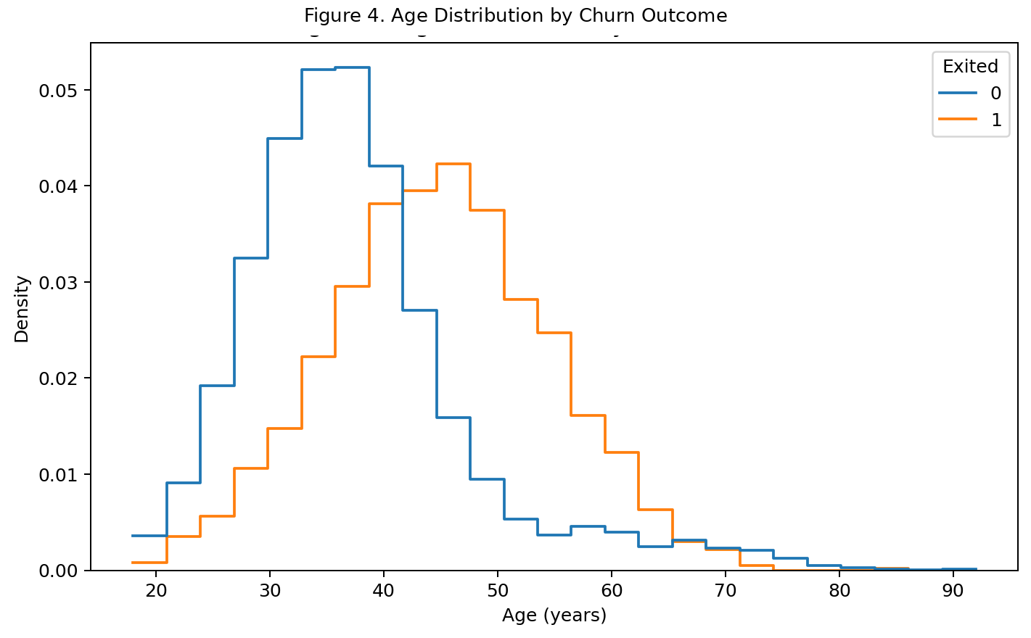
Figure 4. Age Distribution by Churn Outcome.
Interpretation: Age-group comparisons may identify segments with different churn rates. The pattern alone does not explain why customers leave and should be considered with engagement and product-use features.
Age should be examined against churn using grouped summaries or plots. The age pattern is descriptive and does not establish that age causes churn.
Age is explored by comparing distributions or churn rates across age bands. Grouping ages can make a chart easier to interpret, but the bands should be clearly described and should not hide important variation within each group. A box plot or distribution plot can show whether churned and retained customers have different age patterns.
If churn appears more common in certain age ranges, this is a descriptive association within the sample. It may reflect different financial needs, service preferences, account histories, or unobserved circumstances. Age should not be interpreted as a direct cause, and a bank should not assume that all customers in an age group behave alike.

4.5 Tenure and Churn

Statistic | Overall | Stayed | Exited
Mean | 5.01 | 5.03 | 4.93
Median | 5 | 5 | 5
Minimum | 0 | 0 | 0
Maximum | 10 | 10 | 10

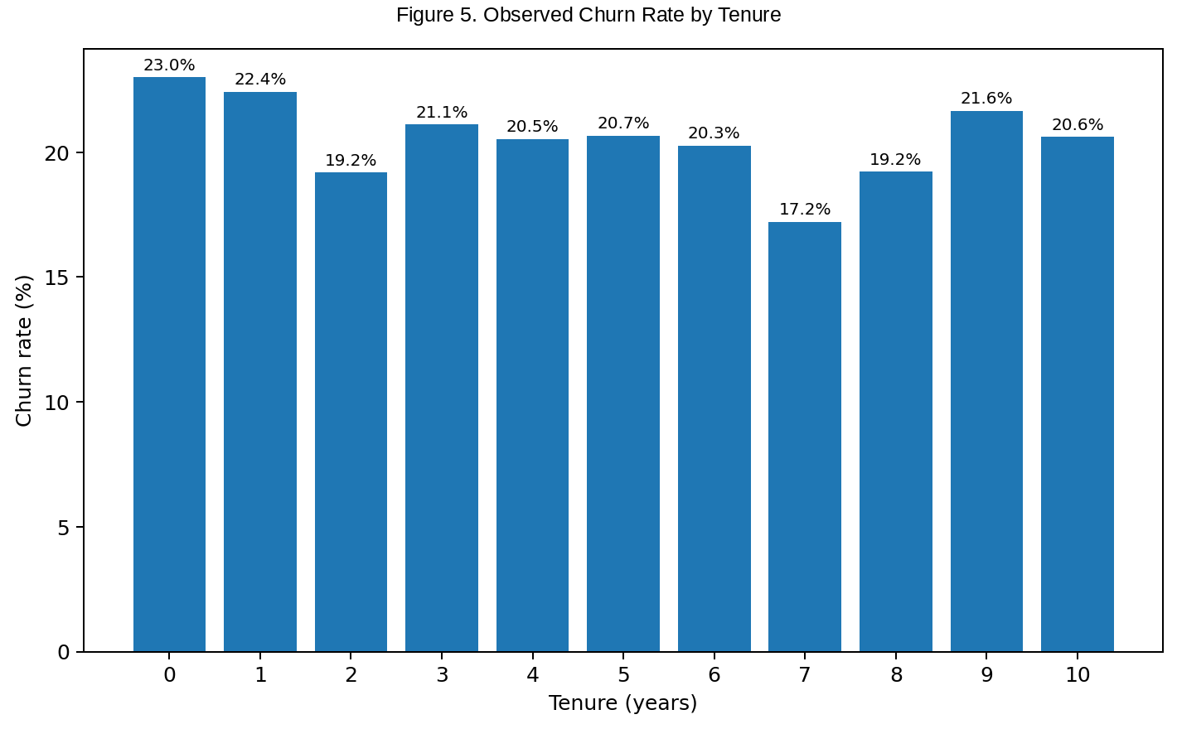
Figure 5. Observed Churn Rate by Tenure.
Interpretation: Tenure analysis can show whether churn is more common among newer or longer-standing customers. This can inform retention-timing hypotheses but does not prove tenure causes churn.
Tenure represents years with the bank. Compare churn rates across tenure groups to identify patterns that may inform retention timing.
Tenure represents how long a customer has been associated with the bank according to the dataset’s definition. Comparing churn rates by tenure can show whether newer and longer-standing customers have different exit patterns. The analysis should use clearly labeled tenure groups and compare percentages within each group.
Tenure may capture relationship maturity, but it may also be correlated with other variables. For example, a longer relationship can be associated with a different product mix or engagement level. A simple chart cannot separate these influences, so tenure-related patterns should be checked alongside model results and, where possible, with more detailed longitudinal data.

4.6 Balance

Statistic | Overall | Stayed | Exited
Mean | 76,485.89 | 72,745.30 | 91,108.54
Median | 97,198.54 | 92,072.68 | 109,349.29
Minimum | 0 | 0 | 0
Maximum | 250,898.09 | 221,532.80 | 250,898.09

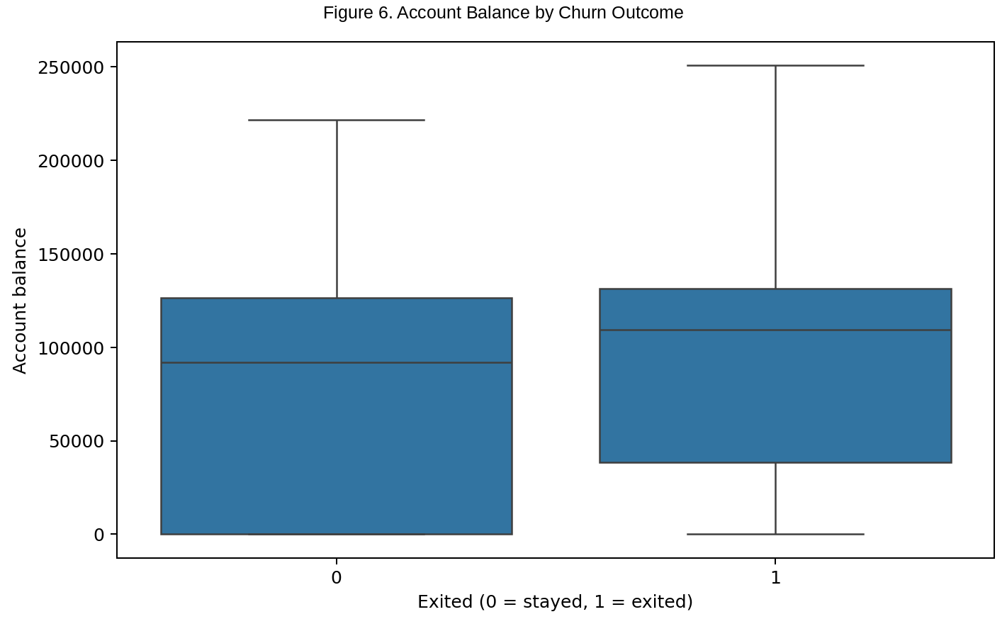
Figure 6. Account Balance by Churn Outcome.
Interpretation: Balance and salary describe different aspects of customer finances. Review their distributions and relationship with churn together, and handle extreme ratios carefully.
Balance and EstimatedSalary are continuous measures. Their distributions may be skewed; median and percentile summaries can be more informative than means alone. The engineered ratio should be checked for extreme values.
Balance and EstimatedSalary are explored through descriptive statistics and distribution plots. These variables may be skewed, contain a large number of low or zero balances, or have values spread across a wide range. Medians and interquartile ranges can therefore be more informative than means alone when extreme values are present.
Comparisons between churned and retained groups can help determine whether balance or salary distributions differ in the sample. Such differences do not necessarily mean that a higher or lower value causes churn. The BalanceToSalaryRatio feature also requires care: if EstimatedSalary is zero or unusually small, the ratio can become undefined or extreme, so safe division and outlier inspection are necessary.

4.7 Number of Products

Number of Products | Total Customers | Exited | Churn Rate
1 | 5,084 | 1,409 | 27.71%
2 | 4,590 | 348 | 7.58%
3 | 266 | 220 | 82.71%
4 | 60 | 60 | 100.00%

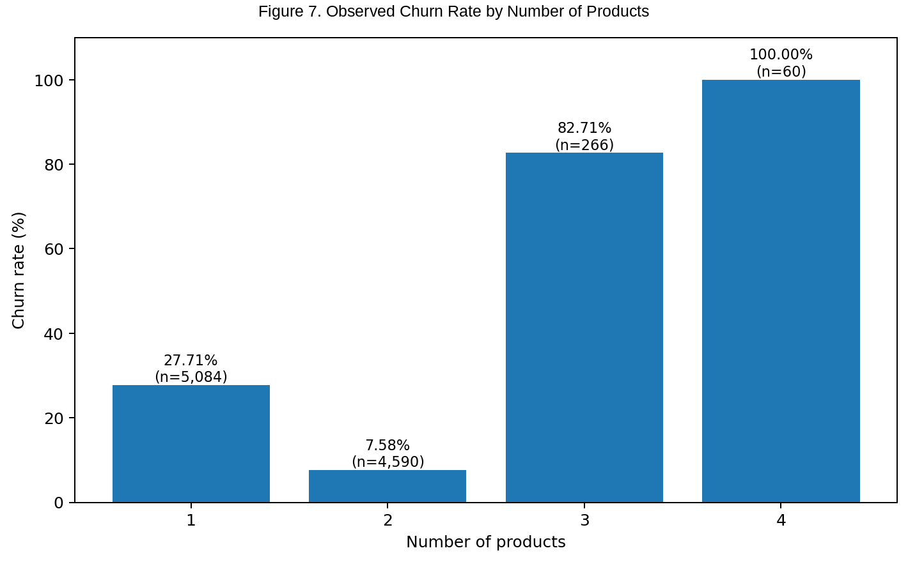
Figure 7. Observed Churn Rate by Number of Products.
Interpretation: Product count may reflect the breadth of a customer's relationship with the bank. Interpret it alongside active-member status because product ownership does not necessarily mean active engagement.
Product count can indicate the breadth of a customer's relationship with the bank. A product count should not automatically be interpreted as engagement; the model evaluates it alongside activity and other features.
NumOfProducts indicates how many bank products are recorded for each customer. EDA compares churn rates across product-count groups and checks whether the relationship is straightforward or non-linear. Product count can be a proxy for relationship depth, but more products do not always mean greater satisfaction or loyalty.
Very low or unusually high product counts should be inspected to understand their frequency and meaning. If customers with particular product counts show high churn, the bank should investigate product suitability, customer needs, and service experience before assuming that adding another product will reduce churn. The chart is a starting point for investigation, not a retention prescription.

4.8 Credit Card Ownership

Credit Card | Total Customers | Exited | Churn Rate
No | 2,945 | 613 | 20.81%
Yes | 7,055 | 1,424 | 20.18%

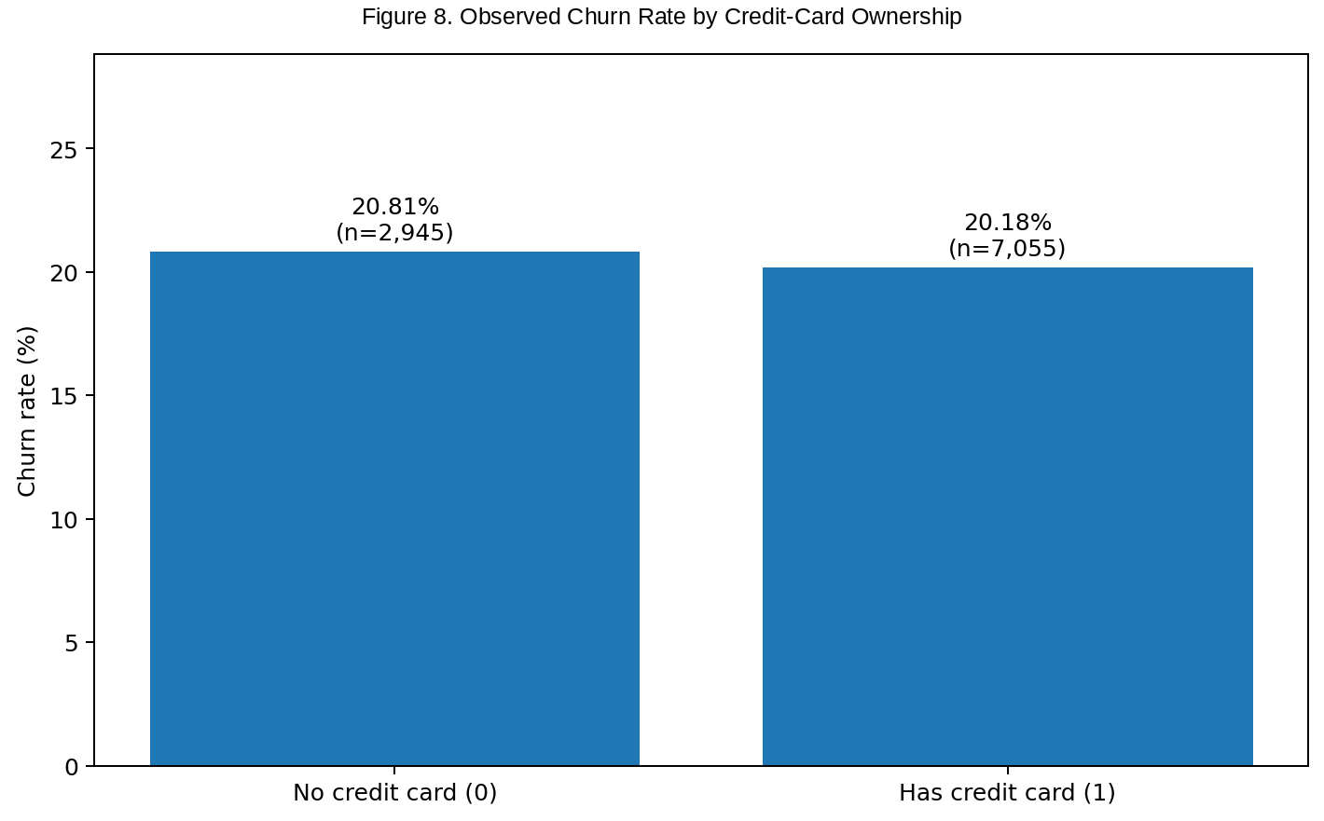
Figure 8. Observed Churn Rate by Credit-Card Ownership.
Interpretation: Group differences may indicate which indicators are associated with churn in this dataset, but they should not be treated as causal effects.
HasCrCard and IsActiveMember are binary indicators. Compare churn rates for both values, while remembering that descriptive group differences are not causal effects.
HasCrCard and IsActiveMember are binary indicators. Their churn rates can be compared by group to see whether recorded card ownership or activity status is associated with exit. For each indicator, both the number of customers and the within-group churn percentage should be shown to avoid confusing population size with risk.

4.9 Active Membership

Active Member | Total Customers | Exited | Churn Rate
No | 4,849 | 1,302 | 26.85%
Yes | 5,151 | 735 | 14.27%

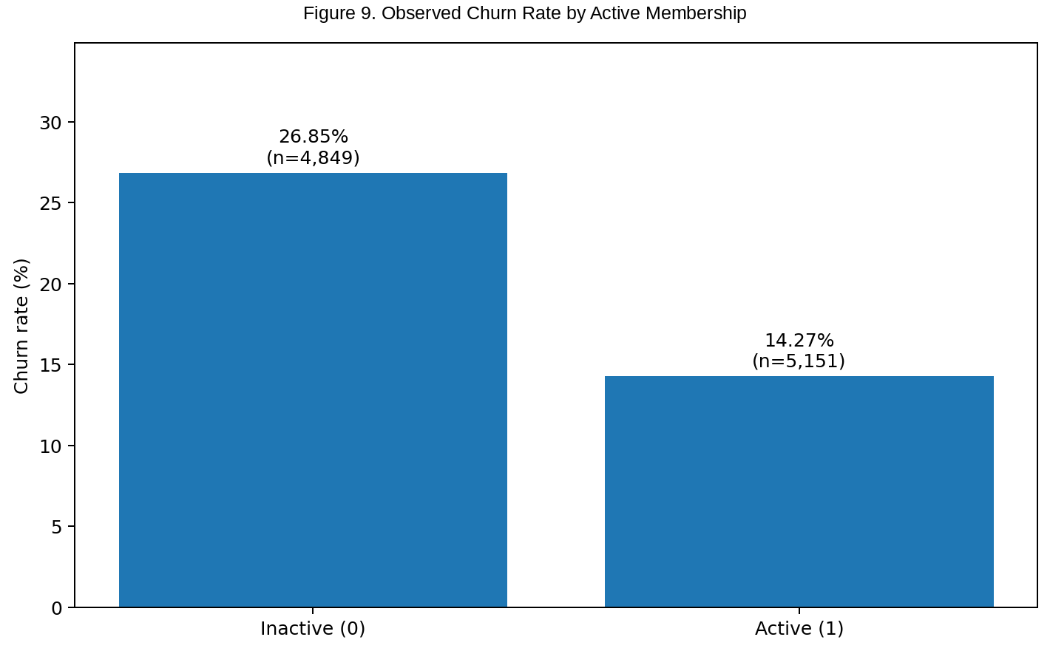
Figure 9. Observed Churn Rate by Active Membership.

Interpretation: The dataset contains 5,151 active members and 4,849 inactive members. The churn rate among inactive customers is 26.85%, compared to 14.27% among active customers. This indicates that inactive customers are more likely to leave the bank than active customers.
Active customers may have a stronger relationship with the bank because of their regular use of its services. In contrast, inactive customers may have lower engagement and may consider switching to other banks.
Therefore, the bank should focus on improving customer engagement through personalized offers, regular communication, and better customer service. Overall, the analysis suggests that active membership is an important factor to consider in customer retention and churn prediction.

4.10 Credit Score
Statistic | Overall | Stayed | Exited
Mean | 650.53 | 651.85 | 645.35
Median | 652 | 653 | 646
Minimum | 350 | 405 | 350
Maximum | 850 | 850 | 850
Standard Deviation | 96.65 | 95.65 | 100.32

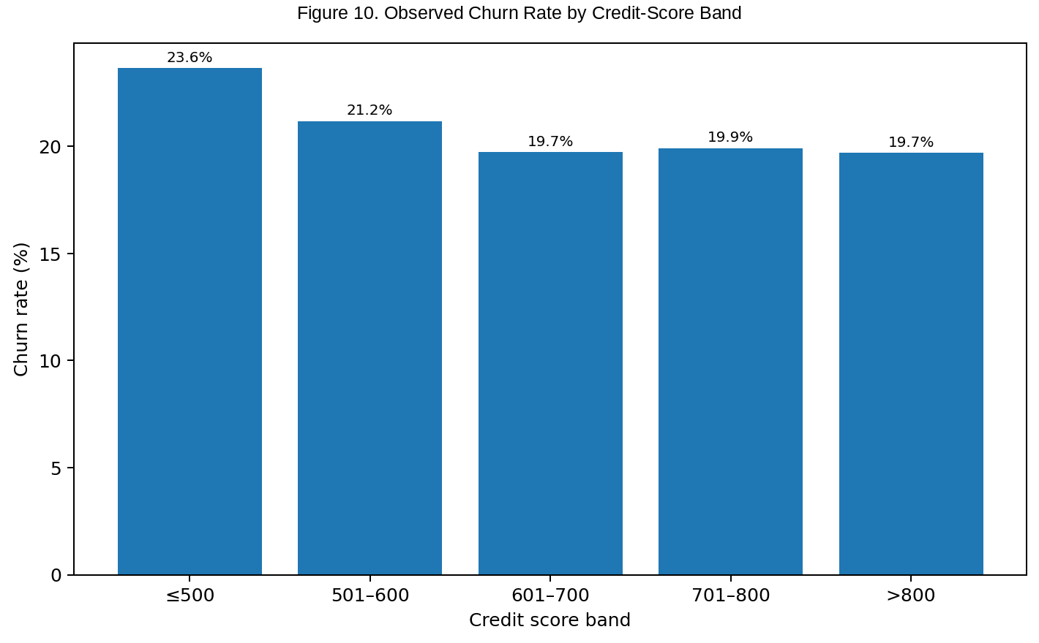
Figure 10. Observed Churn Rate by Credit-Score Band.
Interpretation: Credit score can be explored for an association with churn, but it should not be used in isolation. The model evaluates it alongside other customer characteristics.
CreditScore is a numerical customer attribute. Its association with churn should be interpreted alongside age, geography, product use, and engagement.
CreditScore is examined through summary statistics and by comparing churned and retained distributions. The analysis can reveal whether the groups have different central tendencies or spread, and whether there are unusual values that need validation. Distribution overlap is important: even when average scores differ, many individual customers may have similar scores.
Credit score is primarily a credit-related measure and should not automatically be treated as a direct measure of satisfaction or loyalty. If it contributes to prediction, its role should be evaluated in context and checked for stability and fairness. The model may use it as one signal among several rather than as a standalone rule.

4.11 Salary
Statistic | Overall | Stayed | Exited
Mean | 100,090.24 | 99,738.39 | 101,465.68
Median | 100,193.92 | 99,645.04 | 102,460.84
Minimum | 11.58 | 90.07 | 11.58
Maximum | 199,992.48 | 199,992.48 | 199,808.10
Standard Deviation | 57,510.49 | 57,405.59 | 57,912.42

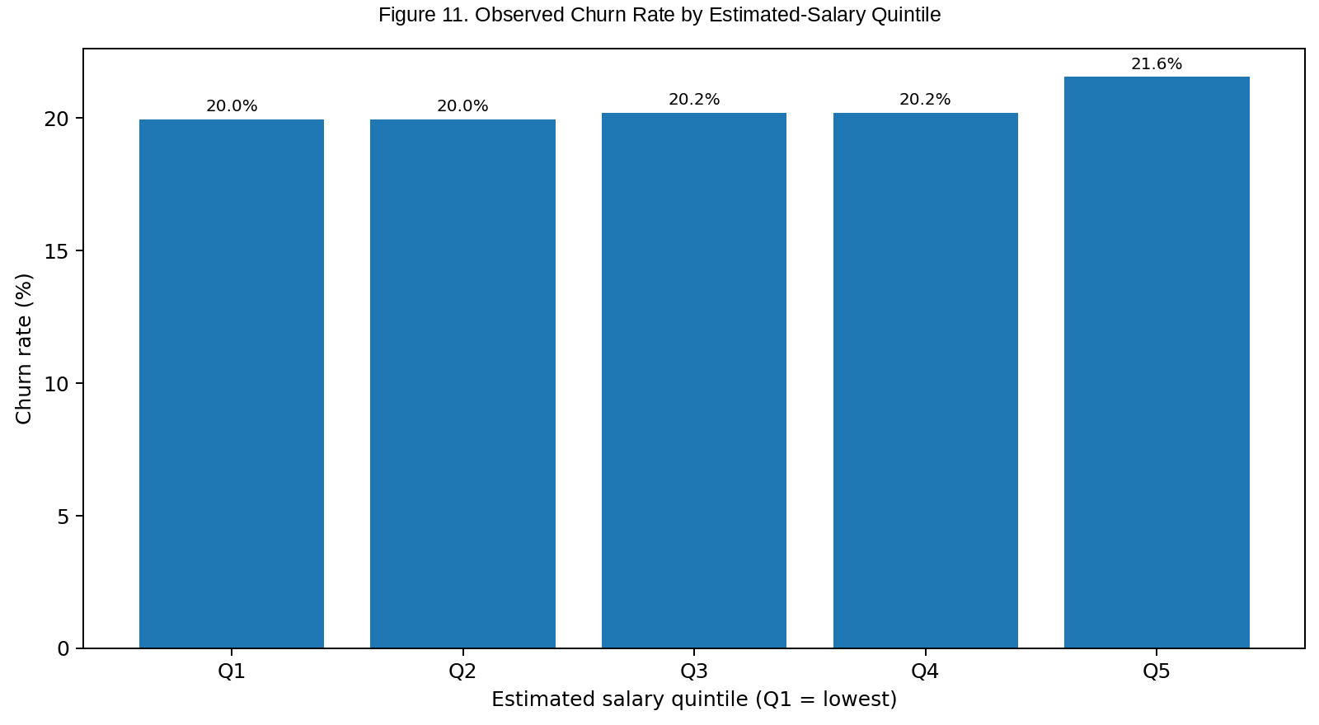
Figure 11. Observed churn rate by estimated salary quintile.

Interpretation: The average estimated salary of all customers is 100,090.24. Customers who stayed have an average salary of 99,738.39, while customers who exited have a slightly higher average salary of 101,465.68. The median salary is also higher among customers who exited.
The salary values vary widely, as shown by the standard deviation of 57,510.49. However, the difference in average salaries between customers who stayed and those who exited is relatively small. Therefore, estimated salary alone may not be a strong indicator of customer churn, and other factors should also be considered when predicting customer exits.

4.12 Numerical Summary

Variable | Mean | Std. dev. | Min | Median | Max
CreditScore | 650.53 | 96.65 | 350.00 | 652.00 | 850.00
Age | 38.92 | 10.49 | 18.00 | 37.00 | 92.00
Tenure | 5.01 | 2.89 | 0.00 | 5.00 | 10.00
Balance | 76485.89 | 62397.41 | 0.00 | 97198.54 | 250898.09
NumOfProducts | 1.53 | 0.58 | 1.00 | 1.00 | 4.00
EstimatedSalary | 100090.24 | 57510.49 | 11.58 | 100193.91 | 199992.48

Interpretation: Descriptive statistics such as count, mean, standard deviation, minimum, quartiles, and maximum provide a compact overview of numeric fields. They help identify scale differences, potential outliers, and variables with limited variation. These summaries should be interpreted with the variable definitions in mind and should not replace plots that show distribution shape.
Where possible, summaries should be calculated separately for churned and retained customers. This helps identify candidate patterns for further modeling, but statistical differences should be considered alongside group sizes and distribution overlap. EDA is exploratory: its purpose is to form and inspect hypotheses, not to claim that each visible difference is statistically significant or causal.

CHAPTER 5: RESEARCH METHODOLOGY

5.1 Research Design
This is a quantitative, predictive study using secondary customer-level data supplied for the project. Supervised machine learning is used because the dataset includes a labeled outcome, Exited.
This study follows a quantitative, applied, and predictive research design. It is quantitative because the analysis uses structured customer records and numerical evaluation metrics. It is applied because it addresses a practical banking problem—identifying customers who may exit—and predictive because the main outcome is an estimate of future or unknown churn status rather than only a description of past records.
The analysis is based on secondary data and uses a supervised learning approach. Historical Exited labels provide the examples from which the models learn. The study is not an experiment and does not randomly assign retention treatments, so it cannot determine whether a particular intervention causes churn to decrease.

5.2 Analytical Workflow
- Load and validate the dataset.
- Define Exited as the target and remove identifier/constant fields.
- Engineer the four derived features.
- Split data using stratified 80/20 sampling.
- Fit preprocessing and four classification algorithms.
- Evaluate using accuracy, precision, recall, F1-score, ROC-AUC, and confusion matrix.
- Select a model based on held-out discrimination and business metric trade-offs.
- Generate feature importance and partial dependence; use SHAP where supported.
- Convert predicted probabilities into illustrative risk bands.
- Integrate the saved model into a Streamlit prototype.
The workflow begins with loading and validating the dataset. The target variable and input fields are inspected, after which exploratory data analysis describes class balance and relationships among available features. The data is then split into training and test sets using stratification, and preprocessing is configured to prevent test information from influencing training.
Four algorithms are trained and compared: Logistic Regression, Decision Tree, Random Forest, and Gradient Boosting. The fitted models are evaluated using the same held-out test set and a consistent set of metrics. The selected model’s probability estimates are then used to demonstrate risk scoring, while feature importance and explainability methods are considered for business interpretation. Finally, the workflow is organized into a prototype Streamlit interface.

5.3 Models Selected
Logistic Regression provides a relatively simple baseline for binary classification and can offer interpretable coefficients when the model is properly specified. It is useful for understanding how a linear decision boundary performs on the available data, although relationships between customer characteristics and churn may be more complex than a linear model can capture.
Decision Tree creates rule-like splits that are easy to explain in principle but can overfit if its depth and leaf sizes are not controlled. Random Forest combines many trees and averages their predictions, often improving stability and capturing non-linear patterns. Gradient Boosting builds a sequence of trees that focuses progressively on errors from earlier stages and can produce strong predictive performance, but its behavior may be less intuitive to explain.
Model | Purpose | Strength | Limitation
Logistic Regression | Interpretable baseline | Simple and efficient | May miss nonlinear patterns
Decision Tree | Rule-based nonlinear model | Easy to explain visually | Can overfit and be unstable
Random Forest | Ensemble of decision trees | Captures interactions and nonlinearities | Less transparent than a single tree
Gradient Boosting | Sequential tree ensemble | Often strong predictive discrimination | Requires careful explanation and tuning

5.4 Evaluation Metrics
Accuracy is the proportion of all predictions that are correct. Precision measures the share of predicted churners who are actually churners, while recall measures the share of actual churners the model successfully identifies. F1-score is the harmonic mean of precision and recall, providing a single summary when both false alarms and missed churners matter.
ROC-AUC measures how well a model ranks churned customers above retained customers across classification thresholds. It is not the same as accuracy and does not specify a single operating threshold. Metrics should be interpreted together because improving recall may reduce precision, and a model that ranks customers well may still need threshold calibration for the bank’s practical costs and capacity.
Metric | Meaning | Interpretation
Accuracy | Correct predictions / all predictions | Overall correctness; can mislead with class imbalance
Precision | True churn predictions / all predicted churn | How many flagged customers actually churned
Recall | True churn predictions / all actual churners | How many churners were identified
F1-score | Harmonic mean of precision and recall | Balances precision and recall
ROC-AUC | Area under receiver operating characteristic curve | Discrimination across thresholds; 0.5 is no better than random ranking

5.5 Ethical and Responsible Use
Predictions should be used to offer appropriate service or support, not to deny customers access to products or treat them unfairly. Demographic variables such as gender and geography require fairness review. The model should be monitored for drift, subgroup errors, data quality, and privacy risks before any production use.

CHAPTER 6: MODEL DEVELOPMENT

6.1 Implementation
The models were implemented in Python using pandas and scikit-learn. A ColumnTransformer applies numeric and categorical preprocessing. Each estimator is trained within a Pipeline so transformations are learned from training data and reused consistently at scoring time.

6.2 Training Configuration
Setting | Value
Train/test split | 80% / 20%, stratified
Random state | 42
Logistic Regression | max_iter = 2000
Decision Tree | min_samples_leaf = 10
Random Forest | 300 trees; min_samples_leaf = 3; balanced_subsample class weighting
Gradient Boosting | 150 estimators; learning_rate = 0.05; max_depth = 2
Primary selection metric | ROC-AUC on held-out test set

6.3 Model Selection
Among the four models, Random Forest produced the highest ROC-AUC on the held-out test set (0.8607). It is selected as the prototype model for the Streamlit application in this run. Selection by ROC-AUC emphasizes ranking ability; the chosen model's default 0.50 threshold is not necessarily the best business threshold.

6.4 Reproducibility
The model artifact and feature metadata are supplied in the accompanying project folder. The fixed random state, feature definitions, and training configuration make this experiment reproducible with compatible Python and library versions.

CHAPTER 7: MODEL EVALUATION AND COMPARISON

7.1 Comparative Results
Model | Accuracy | Precision | Recall | F1-score | ROC-AUC
Decision Tree | 0.8330 | 0.6137 | 0.4840 | 0.5412 | 0.8032
Gradient Boosting | 0.8670 | 0.8133 | 0.4496 | 0.5791 | 0.8606
Logistic Regression | 0.8420 | 0.7136 | 0.3735 | 0.4903 | 0.8363
Random Forest | 0.8575 | 0.6676 | 0.5971 | 0.6304 | 0.8607

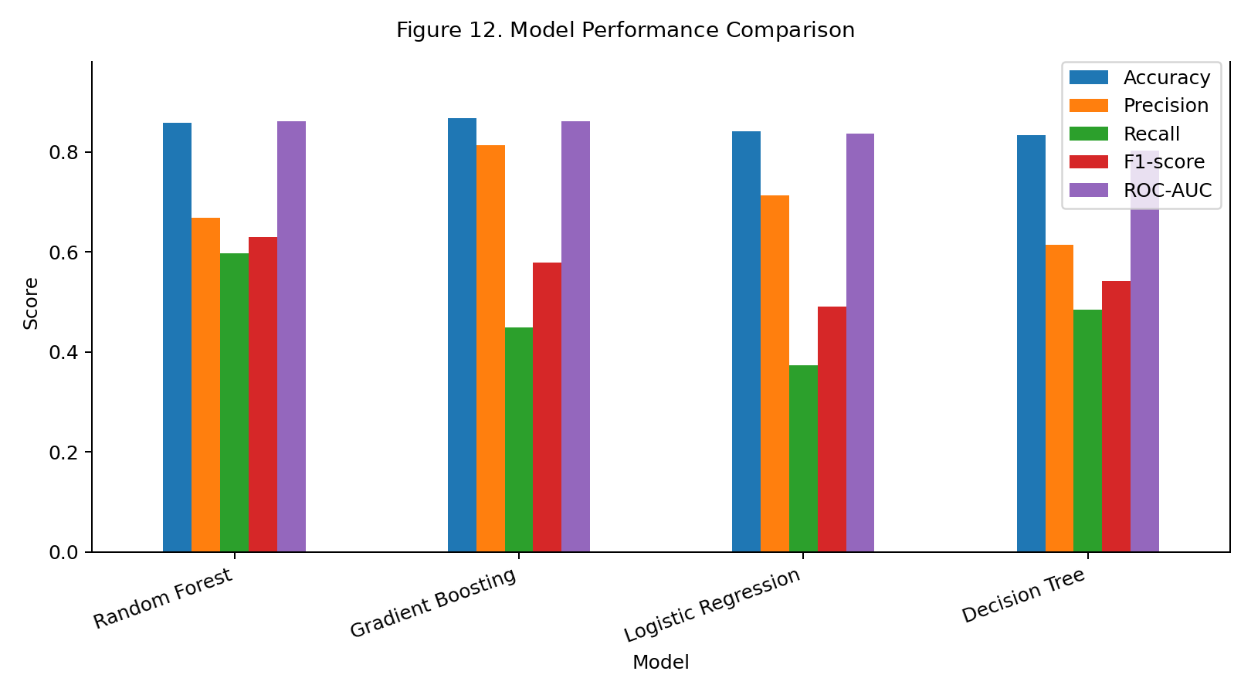
Figure 12. Comparison of evaluation metrics across the four models.
Interpretation: Random Forest has the highest ROC-AUC in this experiment, while Gradient Boosting has the highest accuracy and precision. Model selection should consider the bank’s goals and the cost of missed churners versus unnecessary alerts.
The reported test-set results show that Logistic Regression achieved 84.20% accuracy, 71.36% precision, 37.35% recall, and ROC-AUC of 0.8363. Decision Tree achieved 83.30% accuracy, 61.37% precision, 48.40% recall, and ROC-AUC of 0.8032. Random Forest achieved 85.75% accuracy, 66.76% precision, 59.71% recall, F1-score of 0.6304, and ROC-AUC of 0.8607. Gradient Boosting achieved 86.70% accuracy, 81.33% precision, 44.96% recall, and ROC-AUC of 0.8606.
The table illustrates why a single metric is insufficient. Gradient Boosting has the highest accuracy and precision, while Random Forest has the highest recall among these reported results and the highest ROC-AUC by a very small margin. The Decision Tree has the lowest ROC-AUC of the four. Model selection should reflect the intended use and the cost of different types of error.

7.2 Selected Model Results
The selected model, Random Forest, achieved accuracy of 85.75%, precision of 66.76%, recall of 59.71%, F1-score of 0.6304, and ROC-AUC of 0.8607 on the 2,000-customer test set.
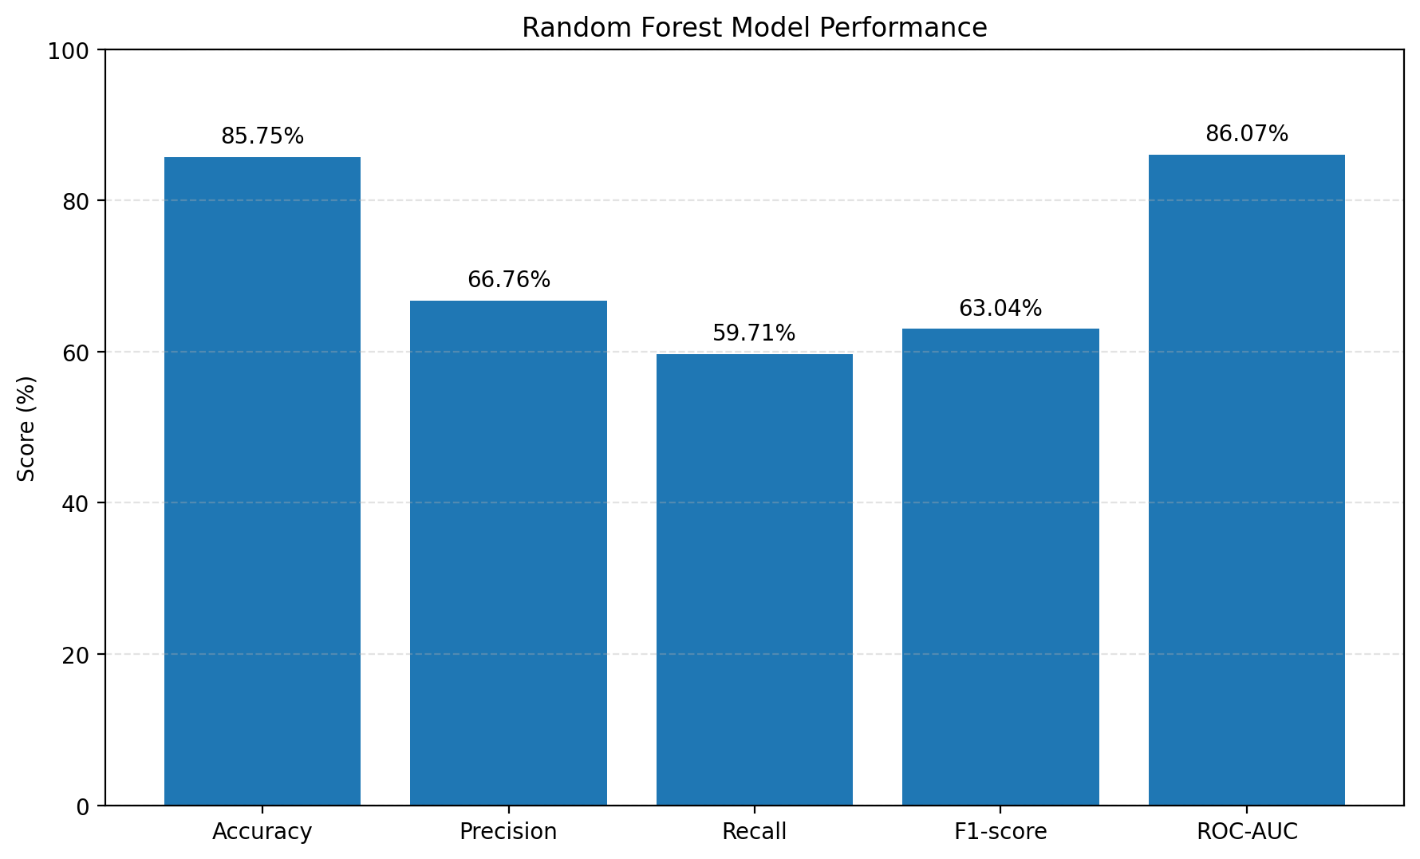
Figure 13. Selected Random Forest model performance metrics.
Interpretation: In practical terms, the model detects some customers who later churn, but it also misses some churners. The result is useful for prioritizing human review, not for making automatic decisions.
Random Forest’s 85.75% accuracy means that approximately 85.75% of the test-set predictions were correct at the evaluated threshold. Its 66.76% precision means that about two-thirds of customers predicted as churners were actually in the churn class in the test data. Its 59.71% recall means it identified about six out of every ten actual churners, while the remaining portion was missed at that threshold.
The ROC-AUC of 0.8607 indicates good ranking ability relative to a random ranking baseline, but it does not mean that 86.07% of individual predictions are correct. ROC-AUC summarizes ranking across thresholds. The selected model is promising for a prototype, but it requires calibration, validation on newer data, and review of performance across customer groups before real use.

7.3 Confusion Matrix
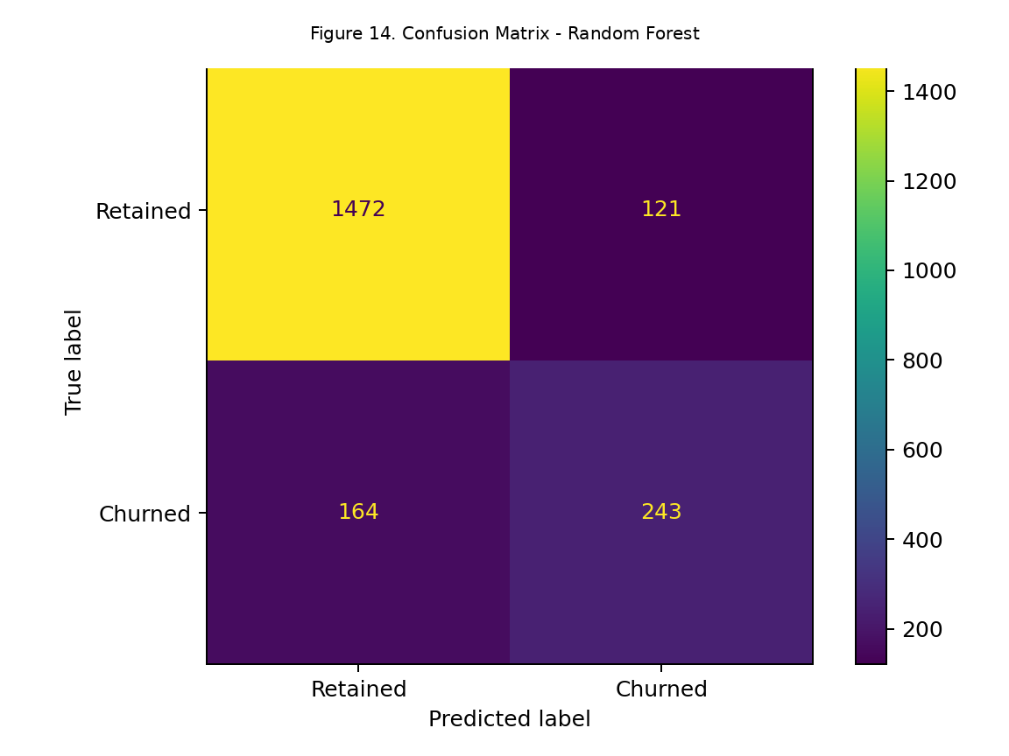
Figure 14. Confusion matrix for Random Forest at the default 0.50 threshold.
Interpretation: The confusion matrix separates correct predictions from false alarms and missed churners. False positives may lead to unnecessary outreach; false negatives are churners the model failed to flag. Both matter when selecting a decision threshold.
A confusion matrix divides predictions into true positives, true negatives, false positives, and false negatives. A true positive is a churned customer correctly identified as churn risk; a true negative is a retained customer correctly identified as retained. A false positive is a retained customer incorrectly flagged as likely to churn, while a false negative is a churned customer the model fails to identify.
These errors have different business consequences. False positives may lead to unnecessary calls, discounts, or retention offers, consuming staff time and potentially annoying customers. False negatives represent missed opportunities to contact customers who eventually leave. The best operating threshold depends on the relative costs of these outcomes and the number of customers the bank can realistically contact.

Outcome | Count | Meaning
True negatives | 1472 | Retained customers correctly predicted retained
False positives | 121 | Retained customers incorrectly flagged as churners
False negatives | 164 | Churners incorrectly predicted retained
True positives | 243 | Churners correctly identified

7.4 ROC Curve
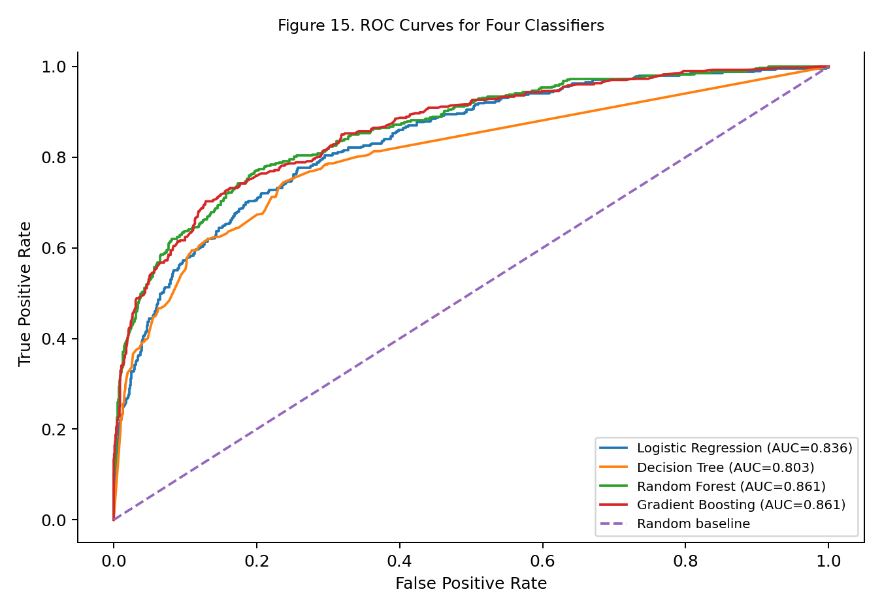
Figure 15. ROC curves for the four classifiers.
Interpretation: The Receiver Operating Characteristic curve plots the true-positive rate against the false-positive rate as the classification threshold changes. A curve closer to the upper-left corner generally reflects better separation between the classes. ROC-AUC compresses the curve into a single ranking metric, making it convenient for comparing models.
ROC analysis is useful when the bank wants to compare ranking ability independently of one fixed threshold. However, if the churn class is rare or if the practical question concerns the number of false alarms among flagged customers, a precision-recall curve may be more directly informative. The model should not be selected from ROC-AUC alone without considering the cost and capacity of the intended action.

7.5 Precision–Recall Trade-off
At the default threshold, the selected model's precision is 66.76% and recall is 59.71%. Higher thresholds generally reduce the number of customers flagged and may improve precision while reducing recall; lower thresholds may capture more churners but increase false positives. The threshold should be selected with retention cost, contact capacity, and the relative cost of missed churn in mind.
Precision and recall often move in opposite directions as the decision threshold changes. Lowering the threshold usually flags more customers, which can improve recall but may also create more false positives and reduce precision. Raising the threshold generally flags fewer customers, which can improve precision but may miss more customers who will churn.
The project’s results demonstrate this trade-off: Gradient Boosting has higher precision but lower recall than Random Forest at the reported operating point. The bank should choose a threshold after defining how many customers can be contacted and how much it costs to contact them. A threshold should not be chosen merely because it is the default value of 0.50.

7.6 False Positive and False Negative Implications
A false positive can cause unnecessary outreach or retention spending. A false negative means a customer who churns was not flagged. These costs are not necessarily equal. A bank should set an operating threshold based on expected campaign benefit, outreach cost, and capacity rather than choosing a threshold solely for accuracy.
False positives can be costly when retention actions involve discounts, fee waivers, or expensive personal outreach. A large number of false positives may reduce the return on the retention budget. However, some low-cost actions—such as a service check-in or a reminder about useful features—may make false positives less expensive.
False negatives can also be costly because the bank loses the chance to understand a customer’s concerns before exit. A practical program may therefore use risk scores to prioritize outreach rather than make automatic decisions. Human review and customer feedback can help distinguish a genuine service issue from a statistical prediction.

7.7 Cross-validation and Further Tuning
This report uses one stratified holdout split for the reported comparison. For a stronger final study, use stratified k-fold cross-validation and tune model hyperparameters using training data only. Report mean and variation across folds, then evaluate the final locked model once on a separate test set.
Cross-validation would provide a more stable estimate of performance by repeating model evaluation across several folds of the training data. Hyperparameter tuning could test values such as tree depth, number of trees, learning rate, minimum samples per leaf, and class weights. These choices should be made within the training process rather than by repeatedly adjusting the model against the final test set.
Further validation should include calibration checks, threshold analysis, and performance by relevant customer segments. If dates are available, a time-based split is preferable for estimating future performance because random splits may mix records from similar time periods. A production system should also be monitored for data drift and changes in churn behavior.

7.8 Evaluation Conclusion
Based on the current held-out test results, Random Forest is the best model by ROC-AUC among the evaluated candidates. This is a comparative result for this split, not a guarantee that the same model will perform best on new data.
On the reported held-out test set, all four models show predictive signal beyond a simple all-retained baseline, but their strengths differ. Random Forest is selected for the prototype based on its highest reported ROC-AUC and higher recall than Gradient Boosting. Gradient Boosting remains a competitive alternative when precision and accuracy are prioritized.
The conclusion is conditional on the dataset, split, and current model settings. A model with the strongest metric in one experiment is not automatically the best choice for every bank or campaign. The final operating model should be chosen after defining the business objective, validating probability quality, and evaluating the costs of false positives and false negatives.

CHAPTER 8: MODEL EXPLAINABILITY

8.1 Feature Importance
For tree ensembles, feature importance ranks the predictors used by the fitted model. The importance measure is model-specific and does not indicate causality. One-hot encoded categorical columns may appear as separate features.
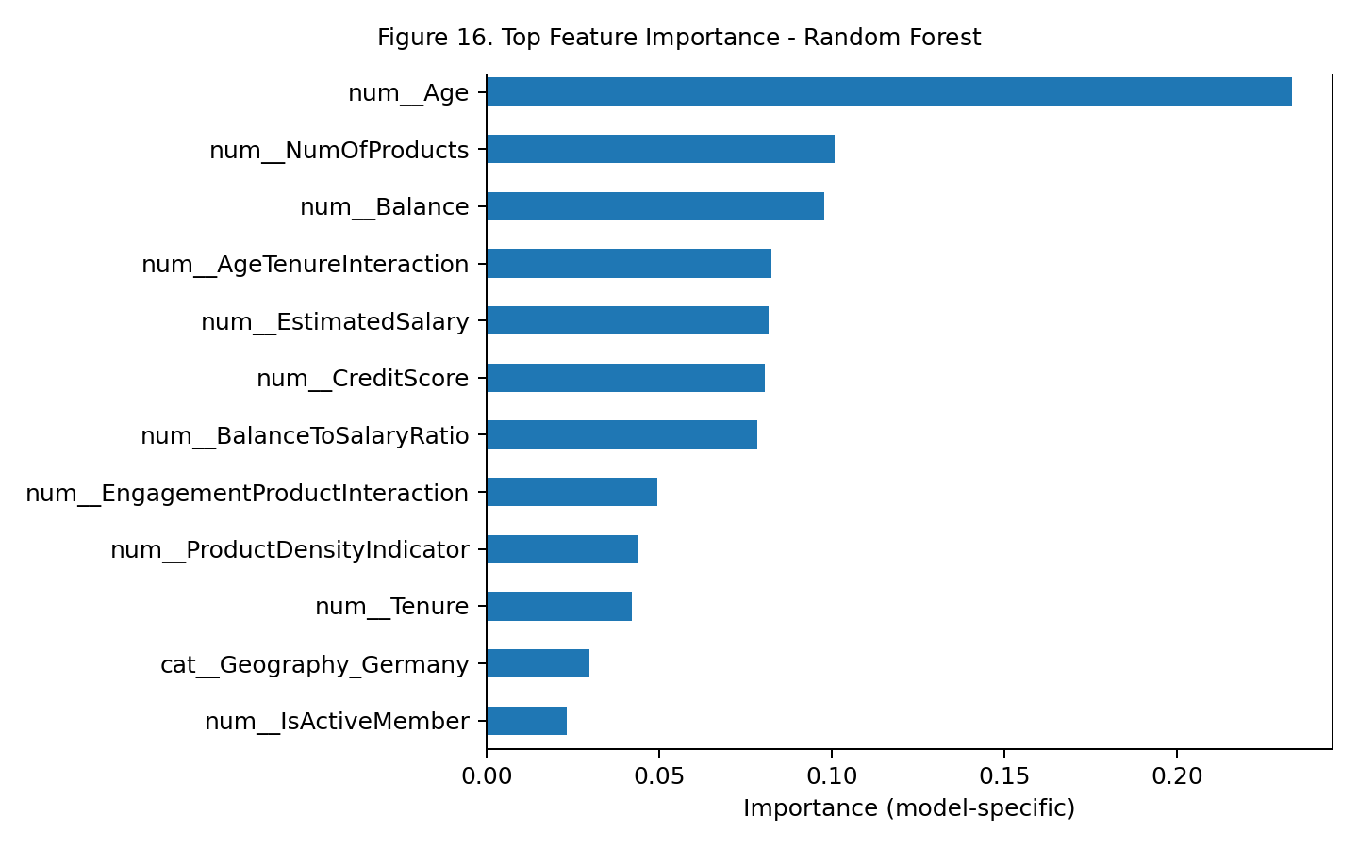
Figure 16. Top model-specific feature importances for Random Forest.
Interpretation: The chart ranks features by their contribution to the selected model’s predictions. Higher importance means the model relied more on that feature; it does not prove that the feature causes churn.
Feature importance methods help analysts understand which inputs contribute most to a fitted model’s predictions. For tree-based models, impurity-based importance summarizes how much a feature contributes to reductions in impurity across tree splits. Permutation importance provides a complementary approach by measuring how much a model’s performance changes when a feature’s values are shuffled.
Importance is not the same as causation. A feature may appear important because it is correlated with another feature or captures a proxy for an unobserved factor. In this experiment, the fitted Random Forest ranked Age (0.23336) first, followed by NumOfProducts (0.10080), Balance (0.09772), AgeTenureInteraction (0.08240) and EstimatedSalary (0.08170). These are model-specific impurity-based scores and do not prove that the features cause churn.

Feature | Importance score
num__Age | 0.23336
num__NumOfProducts | 0.10080
num__Balance | 0.09772
num__AgeTenureInteraction | 0.08240
num__EstimatedSalary | 0.08170
num__CreditScore | 0.08061
num__BalanceToSalaryRatio | 0.07846
num__EngagementProductInteraction | 0.04943
num__ProductDensityIndicator | 0.04374
num__Tenure | 0.04220
cat__Geography_Germany | 0.02969
num__IsActiveMember | 0.02313

8.2 SHAP Analysis
SHAP values were calculated with TreeExplainer for a reproducible sample of 300 records selected from the held-out test set. Figure 15 presents feature contributions for the Random Forest prediction class Exited = 1. Features are ranked by the magnitude of their contributions across the sample. The plot describes the fitted model and is not evidence that a feature causes churn.
SHAP (SHapley Additive exPlanations) attributes contributions from input features to a model output relative to a reference expectation. A summary plot shows the distribution of feature contributions across the sampled records, while a local explanation can examine one prediction. Explanations depend on the fitted model, sample and explainer assumptions.
In this 300-record test sample, Age had the largest mean absolute SHAP value, followed by ProductDensityIndicator, NumOfProducts, EngagementProductInteraction and IsActiveMember. Geography_Germany and Balance also contributed to predictions. Mean absolute SHAP values describe contribution magnitude, not whether changing a variable would reduce churn. Rankings may change for a different sample or refitted model, and feature correlations can affect how contributions are shared.
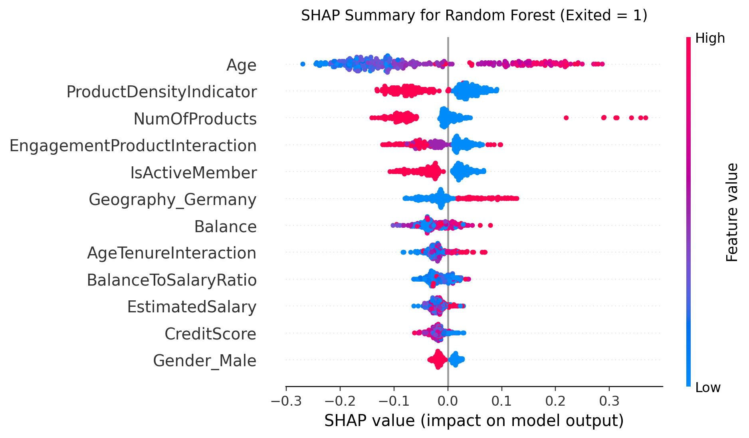
Figure 17. SHAP summary plot for Random Forest predictions of Exited = 1.
Interpretation: The SHAP summary indicates that Age had the greatest average contribution magnitude in the sampled test records. Product density, product count and engagement-related features also contributed to the model output. The colour and horizontal position of points show how feature values relate to the direction and magnitude of SHAP contributions for the churn class; these are model explanations, not causal effects.

8.3 Partial Dependence
Partial dependence plots show the model's average predicted response as a selected feature changes while other features are averaged over the data. They describe model behavior, not a causal effect.
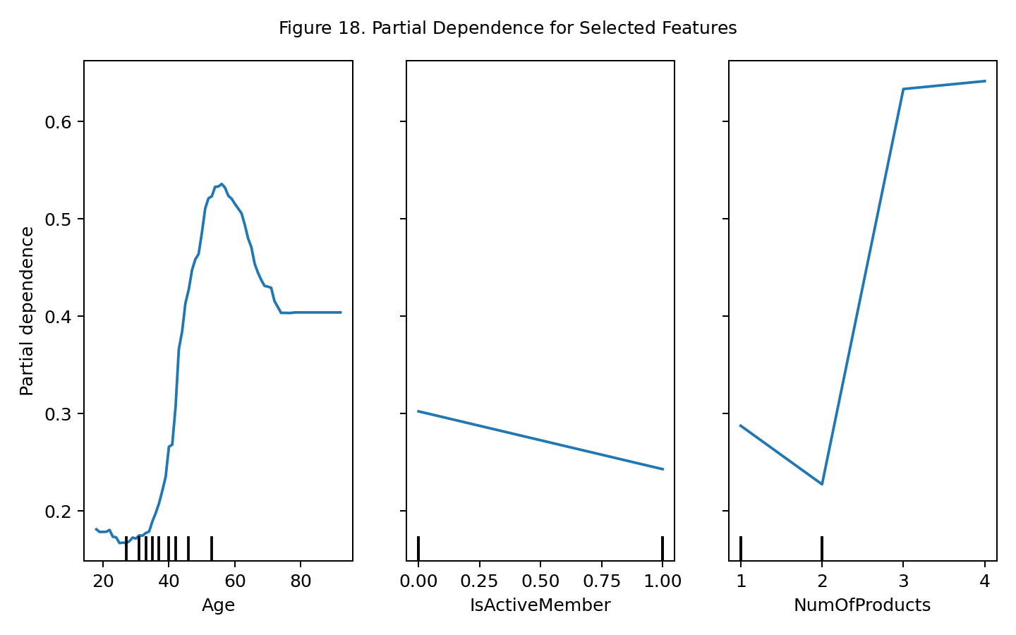
Figure 18. Partial dependence for selected predictors.
Interpretation: Partial dependence shows how the model’s average prediction changes as a selected feature varies. It explains model behavior and does not prove that changing a feature will directly change real customer churn.
Partial Dependence Plots (PDPs) describe the model’s average predicted response as one or two features vary, while averaging over the other observed features. They can help illustrate whether a fitted model’s predictions change gradually, non-linearly, or in a more complex pattern as an input changes.
PDPs can be misleading when features are strongly correlated because they may evaluate combinations of values that are rare or unrealistic in the data. They also describe the model, not the real-world causal effect of changing a customer attribute. Any PDP should be accompanied by a clear statement of its assumptions and limits.

8.4 Explainability Limitations
Feature importance and SHAP can be affected by correlated predictors and the selected sample. They do not prove that changing a feature will change a real customer's behavior. Explainability results should be reviewed by domain experts and combined with appropriate fairness and stability checks.

CHAPTER 9: CHURN RISK SCORING

9.1 Churn Probability
For each customer, the selected classifier estimates P(Exited = 1 | customer features). This value ranges from 0 to 1 and can be displayed as a percentage. The probability should be interpreted as a model estimate, and calibration should be checked before treating it as a real-world frequency.
A classification model can return a probability estimate for the churn class. For example, a probability of 0.72 corresponds to an estimated 72% churn probability under the model’s learned patterns and calibration. It should not be interpreted as a guarantee or as a precise statement of an individual customer’s future behavior unless probability calibration has been assessed.
Probability quality matters because the score may be used to allocate retention resources. Calibration can be checked by comparing predicted probabilities with observed churn rates across probability groups or by using a calibration curve and a suitable numerical measure. If a model is poorly calibrated, the ranking may still be useful, but the numerical probability should be interpreted cautiously.

9.2 Risk Score
A simple 0–100 risk score can be calculated as predicted churn probability multiplied by 100. For example, a predicted probability of 0.37 corresponds to a score of 37/100. This is a rescaled probability, not an independent measure.
For ease of communication, the predicted churn probability can be converted to a 0–100 risk score by multiplying the probability by 100. A probability of 0.37 therefore becomes a risk score of 37. The score provides a convenient common scale for sorting or grouping customers.
The score is an estimate generated by a model, not a credit score and not a measure of customer worth. It should not be confused with a probability of financial default or with the bank’s assessment of credit risk. Its intended meaning is limited to the modeled churn outcome in the supplied dataset.

9.3 Risk Categories
Category | Rule used in prototype | Suggested response
Low | Probability < 0.20 | Continue normal service and monitoring
Medium | 0.20 ≤ probability < 0.50 | Review engagement and consider relevant support
High | Probability ≥ 0.50 | Prioritize human review and targeted retention outreach

These cutoffs are illustrative project thresholds, not industry standards or optimized business thresholds. The application and report use the same bands for consistency. A real bank should validate thresholds against campaign capacity, costs, and observed outcomes.
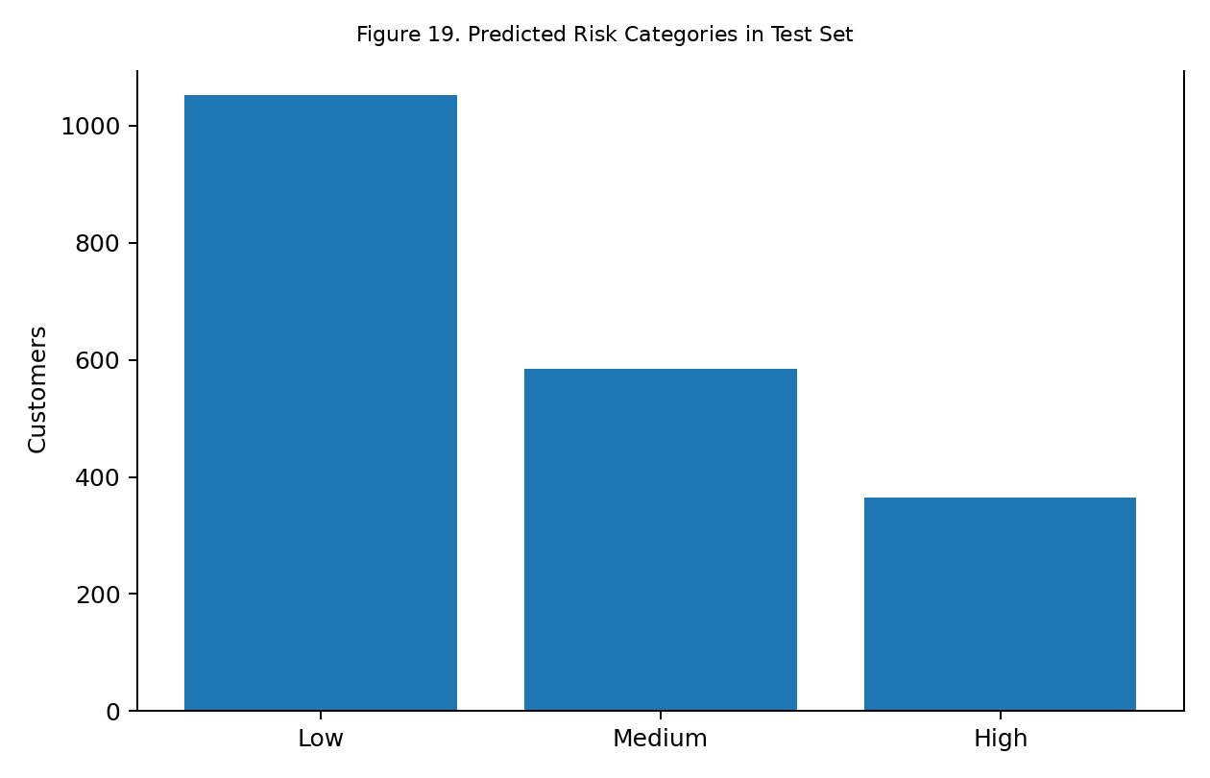
Figure 19. Test-set distribution across the illustrative risk bands.
Interpretation: The chart groups test customers using illustrative bands: Low below 20%, Medium from 20% to below 50%, and High at 50% or above. These cutoffs should be validated against retention costs and campaign capacity before real use.
The prototype uses illustrative bands: Low risk for a score below 20, Medium risk for a score from 20 to below 50, and High risk for a score of 50 or above. These bands make the dashboard easier to read and can support a demonstration of how scores might be grouped for follow-up.
These thresholds are not statistically validated or optimized for a real bank. The bank should select thresholds based on historical validation, the cost of different actions, outreach capacity, customer experience, and fairness checks. A customer in the high-risk group should receive review and appropriate support, not automatic penalties or a guaranteed discount.
Test-set risk band | Customers
Low | 1052
Medium | 584
High | 364

9.4 Threshold Selection
A threshold translates continuous probabilities into a binary flag or category. To select it responsibly, compare precision, recall, false positives, false negatives, expected retention value, and campaign capacity over candidate thresholds. This project uses 0.50 for binary evaluation and 0.20/0.50 for risk bands as transparent illustrative defaults.
A classification threshold converts a probability into a predicted class. A 0.50 threshold is common for demonstrations, but it is not automatically optimal. The appropriate threshold depends on whether the bank values finding as many churners as possible, minimizing false alarms, or maximizing the return on a limited retention budget.
Threshold selection can be framed as a business decision. The bank may estimate the cost of an outreach attempt, the average value of retaining a customer, the probability that an intervention works, and the available number of contacts. It can then compare strategies at different thresholds. Such an analysis requires reliable cost and intervention data, which are outside the supplied dataset.

9.5 Example Scoring
In the application, a user enters a customer's profile and receives the estimated probability, a Low/Medium/High category, and an optional what-if comparison. The probability can change when engagement or product count is adjusted. The difference is a model sensitivity result, not evidence that the intervention will cause churn to fall.
Suppose a customer’s model-generated churn probability is 0.42. The corresponding score is 42 out of 100, which falls in the prototype’s Medium band. A sensible next step would be to review available customer information and consider a proportionate service check rather than conclude that the customer is certain to leave.
The example is illustrative; it is not a claim about a particular real customer. In a deployed system, the score should be stored with the model version, scoring date, and relevant input snapshot so that it can be audited and compared with the eventual outcome. The bank should also avoid repeated or intrusive contact based only on an algorithmic label.

CHAPTER 10: STREAMLIT APPLICATION

10.1 Application Objective
The Streamlit application translates the fitted model into a simple interactive interface. It is a prototype for academic demonstration and is not connected to a bank's live systems. The accompanying folder contains app.py, the trained model artifact, metadata, dataset copy, requirements, and figures.
The Streamlit prototype is intended to demonstrate how a trained churn model can be presented through a simple web interface. A non-technical user should be able to review summary information, enter customer attributes, obtain a churn probability, view a risk category, and explore selected model insights without writing code.
The application is a prototype for academic demonstration. Its presence does not establish that it has been tested in a bank environment or that it is secure, scalable, or approved for operational decisions. The model, preprocessing pipeline, and input fields must remain aligned; otherwise, the application could produce invalid or misleading predictions.

10.2 Executive Dashboard
The application displays predicted churn probability, a threshold-based binary churn flag (Yes/No), risk category, and the selected model. A probability progress indicator provides a quick visual cue. The interface includes an explanation that predictions are estimates and should not be used as the sole basis for decisions. The binary flag uses the illustrative 0.50 threshold stored with the model metadata; it is not an optimized business rule.
The dashboard includes a predicted-churn probability distribution chart calculated for the supplied customer file, alongside the individual customer prediction and model risk category. The chart is descriptive: the supplied file includes records used during model development, so it is not an independent validation distribution. The dashboard should clearly distinguish historical outcomes from model predictions.
Dashboard summaries should clearly distinguish historical outcomes from model predictions. The historical churn rate describes the supplied data, while the probability distribution describes model output. Charts should include titles, labels, and the date or model version used to produce them. If the dashboard uses a static test dataset, this should be stated so that users do not assume it reflects live customers.

10.3 Customer Churn Risk Calculator
The sidebar allows the user to enter credit score, geography, gender, age, tenure, balance, product count, credit-card ownership, active-member status, and estimated salary. The app engineers the same four derived features used during training and passes the row to the saved preprocessing-and-model pipeline.
The risk calculator accepts the input variables required by the saved pipeline, applies the same preprocessing steps used during model training, and returns a predicted churn probability. The interface should validate numeric ranges, required fields, and category choices before scoring. It should also show a clear explanation that the score is an estimate and not a guarantee.
The calculator should not ask for unnecessary identifying information such as a customer’s surname or account identifier when those fields are not model inputs. It should handle invalid or missing values gracefully and should not silently substitute values that materially change the prediction. Any production version would require authentication, access controls, logging, and privacy review.

10.4 Feature Importance Dashboard
The application shows the fitted estimator's feature importance when supported. The values are model-specific. They are not causal explanations and may need to be supplemented with SHAP and domain review.
The feature-importance view helps users understand which variables the fitted model relied on most strongly in the training dataset. It may present a ranked bar chart and a short explanation of the importance method. The view should state whether importance is based on impurity reduction, permutation, or another method because the methods answer slightly different questions.
Feature importance should be read as a description of model behavior, not proof that a feature causes churn. Correlated variables can share or obscure importance, and importance can change when the training data or model settings change. If a genuine importance chart is not available in the application, the report should describe the intended feature rather than claim that the chart was successfully tested.

10.5 What-if Scenario Simulator
The what-if simulator lets a user change active-member status and number of products, then compares the new estimated probability with the original probability. The app labels this as sensitivity analysis and does not claim the change is a causal intervention.
A what-if simulator allows a user to change selected input values and observe how the model’s predicted probability changes. This can be useful for understanding model sensitivity and for exploring hypothetical cases, but it must not be presented as proof that changing a customer attribute will change the real customer’s behavior.
Some inputs, such as age or geography, are not appropriate targets for intervention, and even apparently actionable fields may be proxies rather than causes. The simulator should be framed as an educational tool for model behavior, not as a recommendation engine that tells staff to manipulate customer attributes.

10.6 Batch Scoring
The batch-scoring module accepts a CSV containing the required customer features, computes the engineered variables, generates churn probabilities, threshold-based binary churn flags and risk categories, and allows the results to be downloaded. It validates that required columns are present.
Batch scoring allows the user to upload a file containing multiple customer records and receive churn probabilities, threshold-based Yes/No flags and Low/Medium/High risk categories for each scored row. The current prototype checks required columns; stronger type validation, rejected-row reporting and secure file handling should be added before operational use.
Before operational use, batch scoring should include file-size limits, secure handling of uploaded files, validation against the trained feature schema, and a clear policy for storage and deletion. Predictions should be versioned and monitored. A batch score should not automatically trigger a customer contact or financial decision without a documented review process.

10.7 How to Run the Application
1. Extract the accompanying ZIP folder to your computer.
2. Install Python 3.10 or later.
3. Open Command Prompt or terminal in the extracted project folder.
4. Run: pip install -r requirements.txt
5. Run: streamlit run app.py
6. Open the local URL shown in the terminal, usually http://localhost:8501.
The intended workflow is to install the Python dependencies listed in the project requirements file, ensure that the dataset and saved model artifacts are available in the expected project folders, open a terminal in the project directory, and run the Streamlit entry-point script. The exact command should match the filename included in the delivered project package, commonly `streamlit run app.py`.
If the app reports a missing package or file, the user should check that the correct virtual environment is active and that the project directory structure has not changed. The model should be trained or loaded using the same feature schema as the interface. A successful launch should be confirmed on the user’s own computer before the report states that the application is fully operational.

10.8 Application Screenshots
The app source and trained model are provided for you to run locally. Screenshots should be captured after running the application on your computer because screenshots from an unlaunched app would not verify that the UI works in your environment. Insert screenshots of the dashboard, risk calculator, feature importance, what-if simulator, and batch scoring here after testing.
Screenshot 10.1: Main dashboard and predicted risk
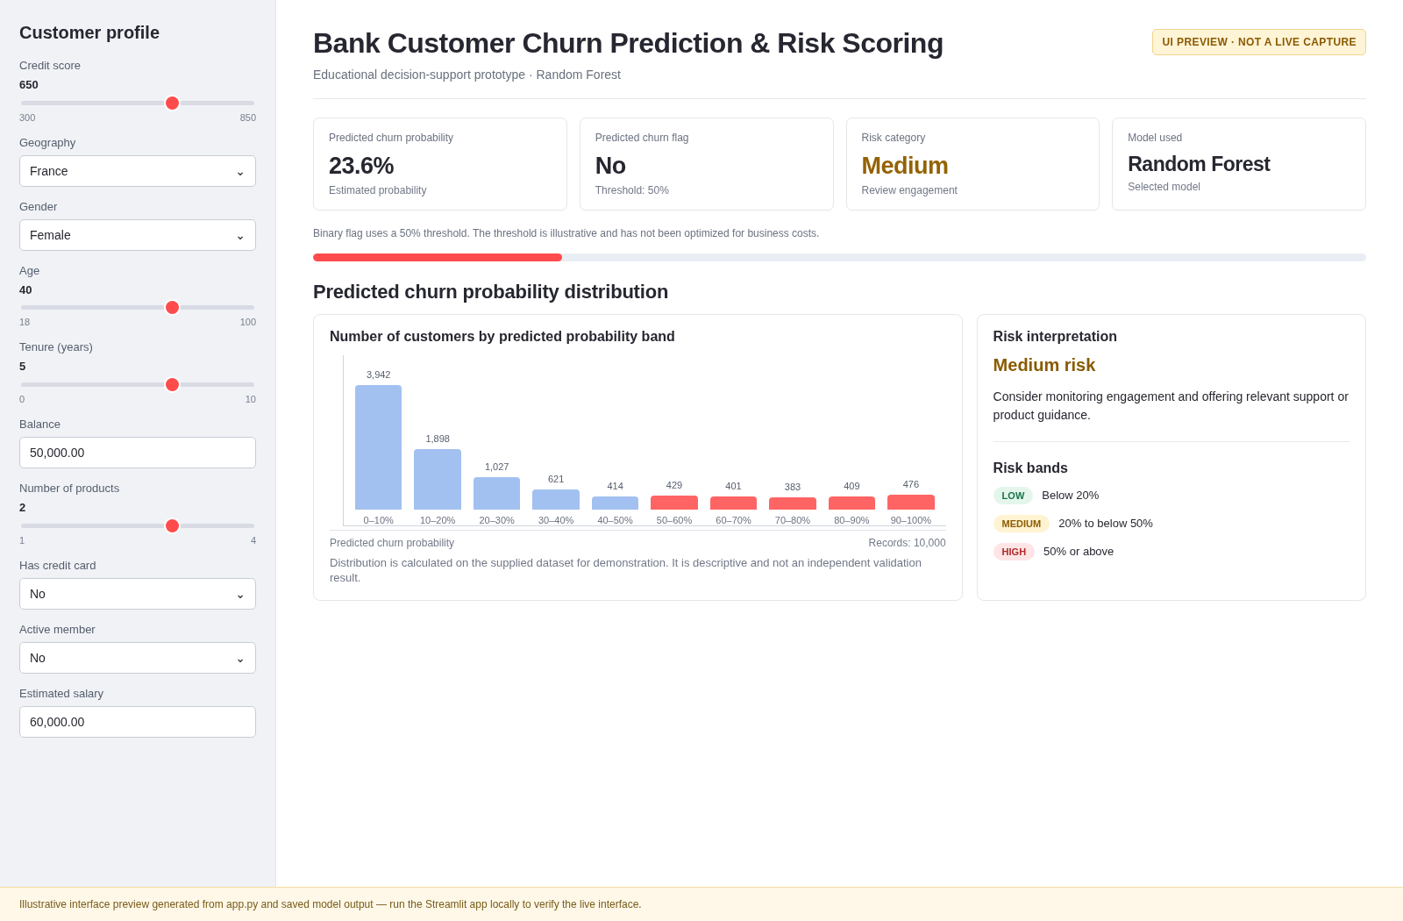

Screenshot 10.2: Customer input calculator —
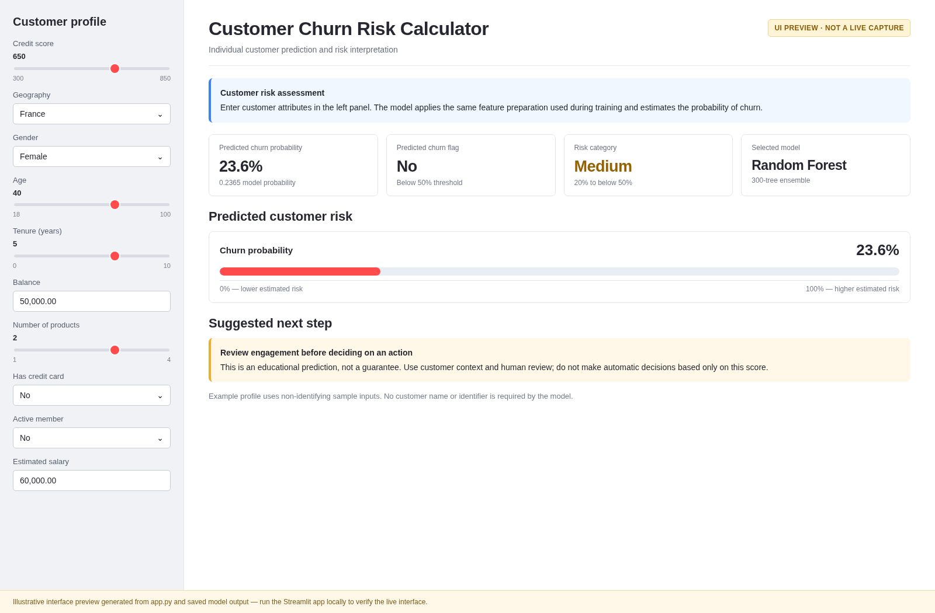

Screenshot 10.3: Feature importance section
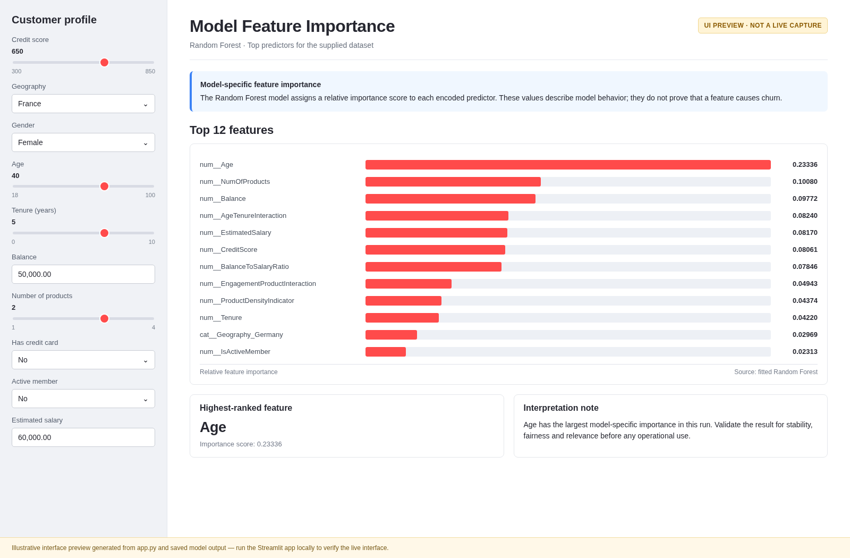

Screenshot 10.4: What-if simulator
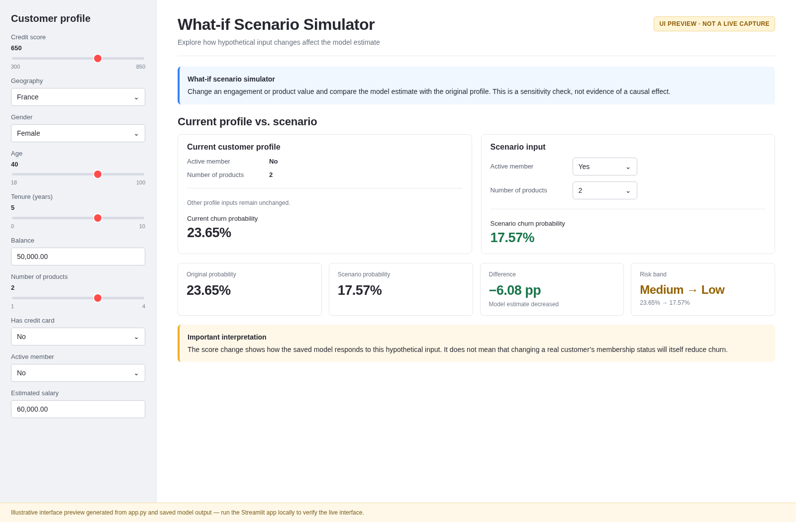

Screenshot 10.5: Batch scoring
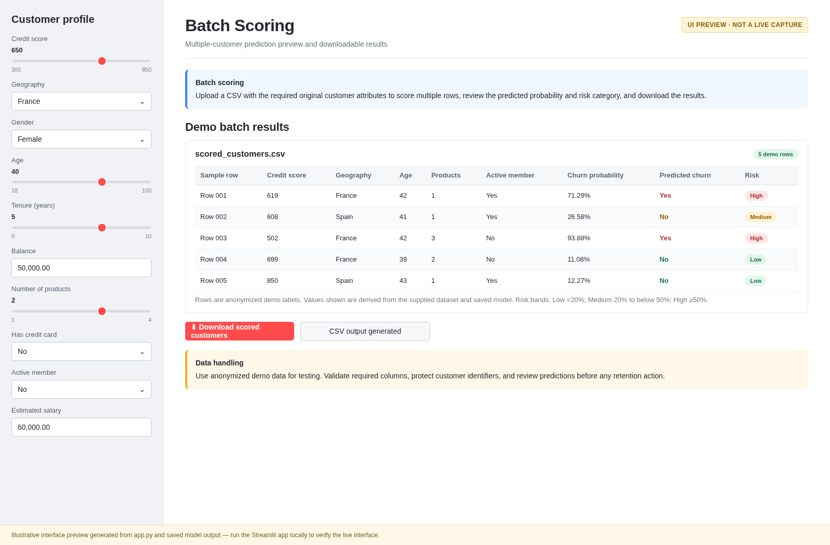

10.9 Application Limitations
The prototype is not authenticated, is not connected to a live database, and has not undergone security, privacy, accessibility, or production deployment review. Model artifact compatibility depends on library versions. Validate inputs, protect personal data, and test the complete application before demonstration.
The prototype demonstrates a workflow but does not establish production readiness. It may lack authentication, role-based access, encrypted storage, monitoring, audit logging, automated retraining, and formal model governance. It also depends on the quality and compatibility of the dataset and the saved model artifacts.
A real deployment would require security testing, privacy review, user acceptance testing, probability calibration, fairness assessment, drift monitoring, and a clear process for reviewing outcomes. The application should be treated as a proof of concept until these requirements have been addressed.

CHAPTER 11: FINDINGS, RECOMMENDATIONS AND LIMITATIONS

11.1 Major Findings
- The supplied dataset contains 10,000 records and 14 original columns.
- The observed churn rate is 20.37%; retained customers form the majority class.
- The selected model by held-out ROC-AUC is Random Forest, with ROC-AUC 0.8607.
- The selected model's test-set precision is 66.76% and recall is 59.71%, illustrating a trade-off between unnecessary alerts and missed churners.
- Customer identifiers and a constant year field were excluded; four derived features were added.
- A Streamlit prototype has been prepared to demonstrate individual risk scoring, a probability distribution chart, a binary churn flag, feature importance, what-if analysis, and batch scoring.
The dataset contains 10,000 customer records and an observed churn rate of approximately 20.37%. This means that churn is a meaningful minority outcome in the supplied sample and that the model must be evaluated on its ability to detect churners rather than accuracy alone. The EDA stage provides a structured description of the available customer and account variables.
The four tested models show different strengths. Random Forest achieved the highest reported ROC-AUC at 0.8607 and recall of 59.71%; Gradient Boosting achieved the highest reported accuracy at 86.70% and precision at 81.33%. These results indicate that there is no single model that leads on every metric. The final choice depends on the operational objective and the relative cost of false positives and false negatives.

11.2 Recommendations
- Use risk scores to prioritize human review and appropriate customer support rather than automatically making adverse decisions.
- Evaluate campaign thresholds using expected value, contact capacity, precision, recall, and the relative cost of false positives and false negatives.
- Test probability calibration and monitor performance after deployment.
- Validate on a separate time period and, where possible, on a representative external dataset.
- Review model errors across geography, gender, age groups, and other relevant subgroups.
- Protect customer identifiers and follow applicable privacy, security, and governance requirements.
- Use controlled experiments to evaluate whether retention actions actually reduce churn; prediction alone does not establish intervention effectiveness.
First, the bank should use churn scores to prioritize investigation and supportive outreach, not to automatically restrict services. A high score should prompt staff to review relevant information and identify whether the customer has an unresolved issue or unmet need. Any offer should be appropriate, transparent, and consistent with the bank’s policies.
Second, model selection should be linked to a measurable business objective. The bank should estimate outreach capacity, cost per contact, value of retained customers, and intervention effectiveness. It should then select a threshold that balances recall and precision according to those costs, rather than relying automatically on a 0.50 cutoff.
Third, the bank should improve data quality and expand the feature set where lawful and available. Potentially useful data may include service complaints, digital engagement, transaction frequency, product changes, customer satisfaction, and time-based trends. The organization should also test calibration, fairness, segment-level error rates, and stability over time before using predictions operationally.

11.3 Limitations
- The dataset provenance and representativeness were not independently verified.
- Results come from one stratified holdout split and fixed model settings; cross-validation and hyperparameter tuning are recommended.
- The 0.50 prediction threshold and 0.20/0.50 risk bands are illustrative, not business-optimized.
- Feature importance and partial dependence describe model behavior and are not causal evidence.
- The project does not include external validation, probability calibration analysis, cost-sensitive threshold optimization, or a live banking deployment.
- SHAP values are shown for a 300-record sample of held-out test data; they are model-specific, sample-based explanations and not causal evidence.
- The Streamlit application requires local testing and genuine screenshots before submission.
The study relies on a single supplied dataset and does not independently verify the data’s collection method or representativeness. The dataset has limited behavioral and temporal information, so it cannot fully explain the reasons behind churn. The project is observational and does not establish causal relationships between features and customer exit.
The reported metrics are based on a particular train-test split and model configuration. They may vary with a different sample, preprocessing decision or software version. The risk bands are illustrative, and feature importance, SHAP and partial dependence explain model behavior rather than establish causation. SHAP results are sample-based and should be re-evaluated after model retraining.
The Streamlit application is a prototype and must be tested in the target environment. It should not be described as production-ready without confirming functionality, security, privacy, fairness, and monitoring requirements. These limitations do not make the project invalid; they define the boundaries of what can responsibly be concluded from it.

11.4 Future Scope
Future work may include stratified cross-validation, hyperparameter optimization, XGBoost comparison, calibration curves, precision-recall analysis, threshold optimization based on campaign economics, fairness assessment, drift monitoring, and controlled retention experiments.
Future work can evaluate additional algorithms, use cross-validation and hyperparameter tuning, calibrate predicted probabilities, and compare thresholds based on business costs. If time-stamped records become available, a temporal validation design can test whether the model predicts churn in a later period rather than merely distinguishing records from a random split.
Future research can also incorporate customer satisfaction, complaint history, transaction patterns, service usage, and longitudinal engagement indicators. It can evaluate whether risk-based outreach actually reduces churn through a controlled pilot or carefully designed impact evaluation. Fairness, privacy, explainability, and drift monitoring should be integrated from the beginning rather than added only after deployment.

11.5 Conclusion of Findings
The results show that the supplied customer features contain useful predictive signal for churn classification on the held-out test set. However, no single metric captures all business objectives. A responsible churn program should combine model predictions, transparent risk thresholds, explainability, customer privacy, and measured retention outcomes.
The findings support the feasibility of using structured customer data and supervised machine learning to estimate churn risk in an academic prototype. The comparison demonstrates the importance of evaluating models through multiple metrics and selecting a model in line with the intended business use. Random Forest is a reasonable demonstration choice based on the reported ROC-AUC and recall, while Gradient Boosting is a strong alternative when precision and accuracy are prioritized.
The findings should be used as a starting point for further investigation. A bank would need current, representative data, validated risk thresholds, documented interventions, and ongoing monitoring to establish whether the system creates measurable business value.

CHAPTER 12: CONCLUSION
This project built a reproducible workflow for predictive bank customer churn analysis using the supplied European Bank customer dataset. After validating the data, excluding identifiers and a constant year field, and creating derived features, four classification algorithms were compared on a stratified test set. The model with the highest ROC-AUC in this experiment was selected for the prototype application. The project also defined transparent illustrative risk bands and developed a Streamlit interface for individual scoring, feature importance, what-if analysis, and batch scoring.
The work meets the core analytical and application objectives at a prototype level, but it should not be considered production-ready. The dataset's provenance, model generalization, probability calibration, fairness, and the impact of real retention actions remain to be validated. The main business value is a structured way to prioritize review and test retention strategies rather than a guarantee that a flagged customer will leave.
REFERENCES
- Breiman, L. (2001). Random Forests. Machine Learning, 45, 5–32.
- Friedman, J. H. (2001). Greedy Function Approximation: A Gradient Boosting Machine. The Annals of Statistics, 29(5), 1189–1232.
- Pedregosa, F., et al. (2011). Scikit-learn: Machine Learning in Python. Journal of Machine Learning Research, 12, 2825–2830.
- Streamlit. (n.d.). Streamlit documentation. https://docs.streamlit.io/
- SHAP. (n.d.). SHAP documentation. https://shap.readthedocs.io/
- Dataset: European_Bank(1).csv, supplied by the project author. Dataset provenance not independently verified.

APPENDIX A: STREAMLIT APPLICATION SETUP
The accompanying ZIP folder contains the complete application source and trained model. The key command sequence is shown below.
pip install -r requirements.txt
streamlit run app.py

APPENDIX B: KEY MODEL RESULTS
Metric | Selected model result
Selected model | Random Forest
Accuracy | 0.8575
Precision | 0.6676
Recall | 0.5971
F1-score | 0.6304
ROC-AUC | 0.8607
Train records | 8000
Test records | 2000
Risk band thresholds | Low < 0.20; Medium 0.20–<0.50; High ≥ 0.50

APPENDIX C: IMPORTANT SUBMISSION CHECKLIST
- Fill in student name, roll number, institution, guide, and academic year on the cover page.
- Open the report in Word and update the Table of Contents.
- Run the Streamlit application on your own computer and test all modules.
- Insert genuine screenshots into Chapter 10 after testing.
- Confirm the model result table and confusion matrix against the generated report.
- Ask your guide whether a separate executive summary for government stakeholders is required as an additional deliverable.
- Confirm that the SHAP and partial-dependence figures are present and based on genuine model-generated outputs.

